

**Bachelor of ICT Assessment Cover Sheet**

Complete and attach this cover sheet to your assessment before submitting

**Course Code and Title:**

IT8416 – Data Mining

**Assessment Title:**

Learning Outcomes:

LO1 – Demonstrate critical knowledge and understanding of the fundamental concepts and techniques of Data Mining

LO2 – Utilize data mining software to solve defined and undefined problems.

LO3 – Interpret and evaluate obtained numerical and graphical data to recommend the best model to be used for prediction purposes.

Group Project

Jassim Mohammed Algallaf 201901356/ 201801338 Husain Alwadyani

**Student ID & Name:**

**Tutors:**

Sini Raj Pulari

**Due Dates:**

Sunday, 4th June 2023 by 11:55 p.m.

The maximum grade granted for late submission is 60 % for up to 3 calendar days. A grade of 0 will be allocated for submission after 3 days.

**Late Rule**

***By submitting this assessment for marking, either electronically or as hard copy, I confirm the following:***

* *This assignment is* our **own group work**
* *Any information used has been properly referenced.*
* *I understand that a copy of my work may be used for moderation.*
* *I have kept a copy of this assignment*

Do not write below this line. For Polytechnic use only*.*

**Assessor:**

**Date of Marking:**

**Grade/Mark:**

Contents

**Task 1** 3

Business Goal: 3

Motivation: 3

Objectives: 3

Problem Statement / Project Definition: 4

Technique Decided to Use: 4

Expected Result: 4

**Task 2** 5

Relevance to the Problem Statement: 5

Availability of Essential Attributes: 5

Dataset Size and Adequate Instances: 5

Potential for Real-World Application: 5

Dataset Complexity and Variation: 6

Type of data in each attribute as follows: 6

Presence of missing data and redundant data: 8

**Task 3** 12

**Task 4** 31

Linear Regression: 32

Random Forest: 36

K-NN: 40

Ensample Model: 43

**Task 5** 47

K-NN evaluation: 47

Random forest evaluation: 48

Ensample model evaluation: 49

**Task 6** 50

Model Comparison and Contrast: 50

Insights and Inferences: 50

Recommendations: 50

Reflection: 51

# **Task 1**

## Business Goal:

The primary objective of this project is to develop an accurate and reliable house price prediction model that assists potential buyers, sellers, and real estate agents in making informed decisions. By leveraging data mining techniques and predictive modeling, the goal is to provide an efficient tool that estimates house prices based on various attributes such as the number of bedrooms, number of bathrooms, city, state, house size, acre_lot, and zipcode. This project aims to empower individuals and industry professionals with reliable predictions, enabling them to navigate the real estate market with confidence, make well-informed investment decisions, and optimize their buying and selling strategies. Ultimately, the business goal is to enhance transparency, fairness, and efficiency in the real estate sector by leveraging data-driven insights for pricing properties accurately.

## Motivation:

The motivation behind this project is to provide individuals with a clear understanding of the factors that influence house prices in a specific region. By predicting house prices accurately, potential buyers can make informed decisions about when to purchase a home, ensuring they get the best value for their investment. Additionally, this project aims to combat fraudulent practices in the real estate market by enabling buyers to identify fair prices and avoid being deceived.

## Objectives:

The objectives of this project are as follows:

* Develop a predictive model that can accurately estimate house prices based on various features and historical valuation data.
* Identify and analyze the key factors that significantly impact house prices.
* Provide a user-friendly interface or tool that allows individuals to input relevant information and obtain predicted house prices promptly.
* Improve transparency in the real estate market by empowering buyers with reliable price predictions.

## Problem Statement / Project Definition:

The problem statement for this project is to create a predictive model that can accurately forecast the selling price of houses in a particular region. This model will consider various features such as location, size, number of rooms, amenities, and historical data to make accurate predictions. By addressing this problem, the project aims to assist potential buyers in making informed decisions and ensure fair pricing in the real estate market.

## Technique Decided to Use:

For this project, a data mining technique will be employed to predict house prices. The specific technique chosen is predictive, aiming to build a model that can accurately forecast house prices.

## Expected Result:

The expected result of this project is a robust and accurate predictive model that can estimate house prices in each region. The model should consider a range of relevant features and historical valuation data to generate reliable predictions. Ultimately, the goal is to enable potential buyers to make informed decisions about purchasing a house at the right time and price, while also improving transparency in the real estate market.

# **Task 2**

We have chosen the House Price Prediction dataset due to the following justifications: It follows the project requirement as it has 206k instances with 8 attributes, in addition it also has some missing and redundant data. The data set URL:( <https://www.kaggle.com/datasets/ahmedshahriarsakib/usa-real-estate-dataset> )

## Relevance to the Problem Statement:

* The dataset directly aligns with our problem statement, which focuses on predicting house prices. The attributes provided, including the price, number of beds, number of bathrooms, city, state, house size, acre_lot, and zipcode, are crucial factors that influence house prices. By utilizing this dataset, we can accurately model the relationship between these attributes and the selling price, facilitating informed decision-making for potential buyers.

## Availability of Essential Attributes:

* The dataset contains all the essential attributes required for accurate house price predictions. The price attribute serves as the target variable, while the other attributes capture key factors that impact house prices, such as the location, size, and amenities. The inclusion of these attributes allows us to develop a comprehensive predictive model that considers a wide range of influencing factors.

Dataset Size and Adequate Instances:

* The dataset meets the requirement for a sufficient number of examples, with a minimum of 250 instances (It has 206k instances). A larger data set provides more robust training and evaluation for our predictive model, enabling us to achieve higher accuracy in price predictions. By leveraging a substantial number of instances, we can ensure the reliability and effectiveness of our model.

## Potential for Real-World Application:

* House price prediction is a practical and valuable application in the real estate domain. By accurately predicting house prices, potential buyers can make informed decisions, ensuring they purchase a property at the right time and price. Additionally, the dataset enables us to address concerns related to fraudulent practices in the real estate market, as it empowers buyers to identify fair prices and avoid being deceived.

## Dataset Complexity and Variation:

* A detailed dataset justification is essential, and the House Price Prediction dataset offers complexity and variation necessary for robust analysis. The dataset includes multiple attributes capturing different aspects of the houses, such as size, location, and amenities. This variety of attributes allows for a comprehensive exploration of the factors influencing house prices and enhances the quality of the predictive model.

## Type of data in each attribute as follows:

|  |  |  |
| --- | --- | --- |
| Attribute | Attribute Type | Description |
| Price | Quantitative data | The price of a house is a numerical value representing the monetary amount. |
| Number of beds | Quantitative data | The number of bedrooms is a numerical count. |
| Number of bathrooms | Quantitative data | The number of bathrooms is a numerical count. |
| City | Qualitative data | The city attribute represents categorical information about the location of the house. |
| State | Qualitative data | The state attribute represents categorical information about the location of the house. |
| House size | Quantitative data | The house size attribute represents a numerical value indicating the area or square footage of the house. |
| Acre_lot | Quantitative data | The acre_lot attribute represents a numerical value indicating the size of the lot in acres. |
| Zipcode | Qualitative data | The zipcode attribute represents categorical information about the area or neighborhood where the house is located. |

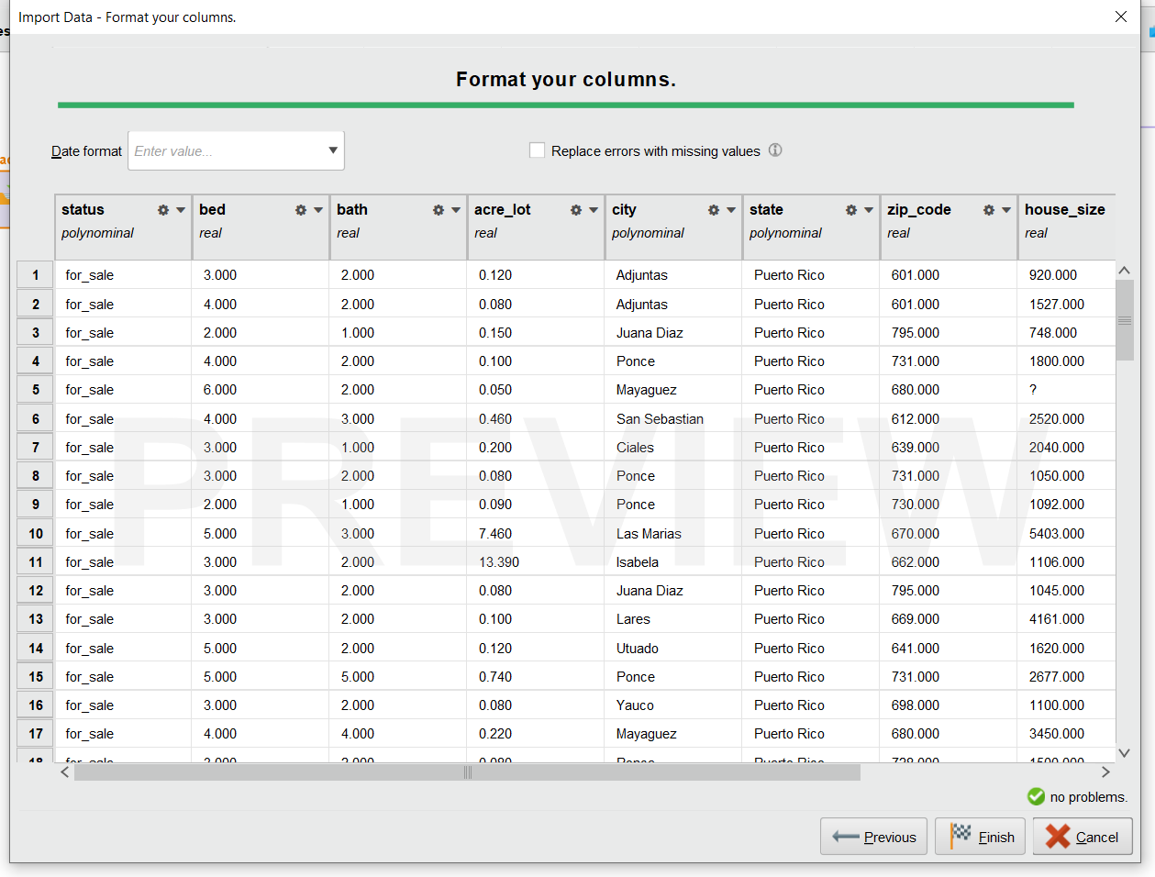After inputting the data set into our decided program to use, which is in this instance Rapid Miner, we can see the following. Which is what are the attributes being input and what are their types.

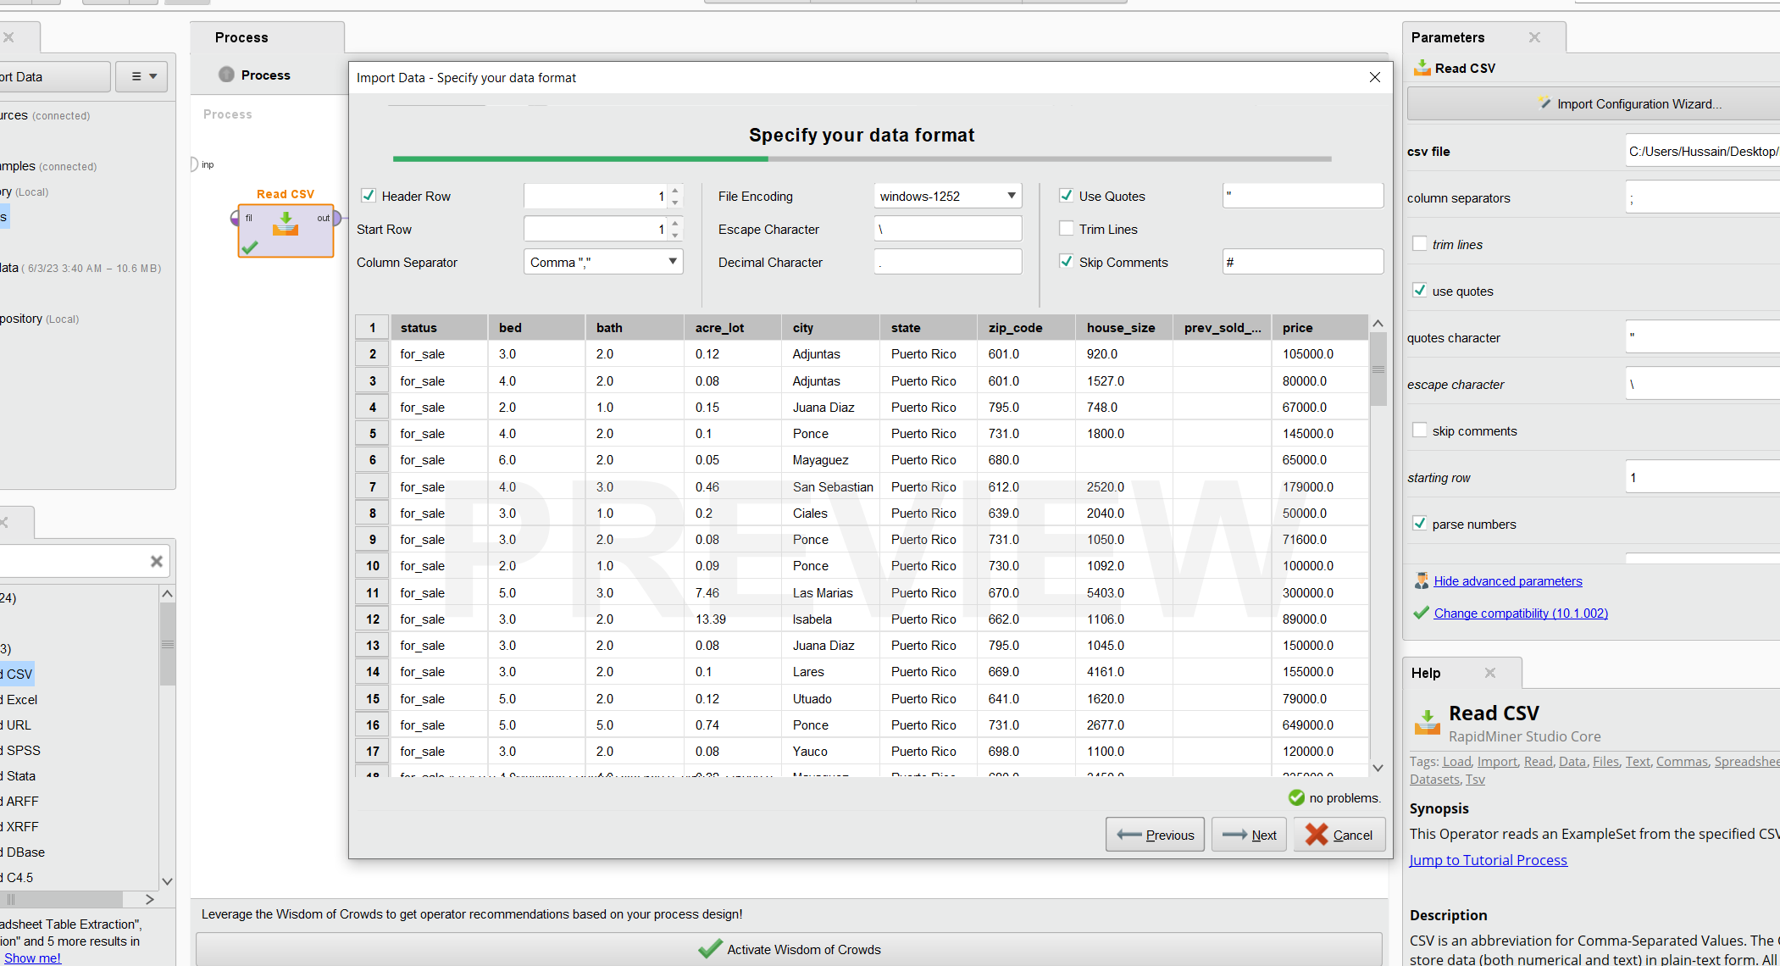

## Presence of missing data and redundant data:

After importing the data set we run it to check a few details. First, is the presence of missing data which we can find in the statistics tab.

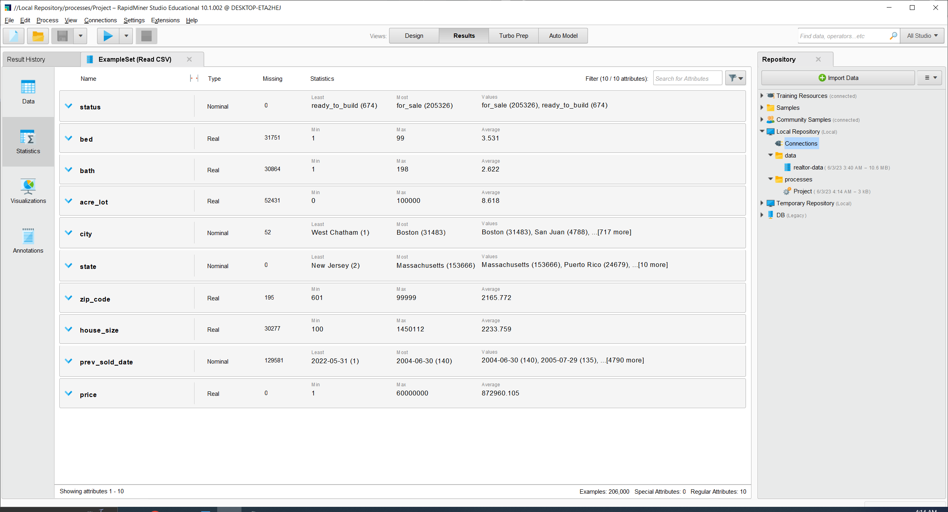

Showing the numbers of missing data in some of the attributes.

* We can see that we have missing values in the attributes (bed, bath, acre_lot, city, zip_code, house_size, prev_sold_date). Furthermore, we have three attributes which identify the location of our specified houses which are city, state, and zip_code. Since these attributes are redundant we will probably only use one of them in our models. Moreover, after using the remove duplicates modifier we can see that our duplicates and redundant data is more than 40000.

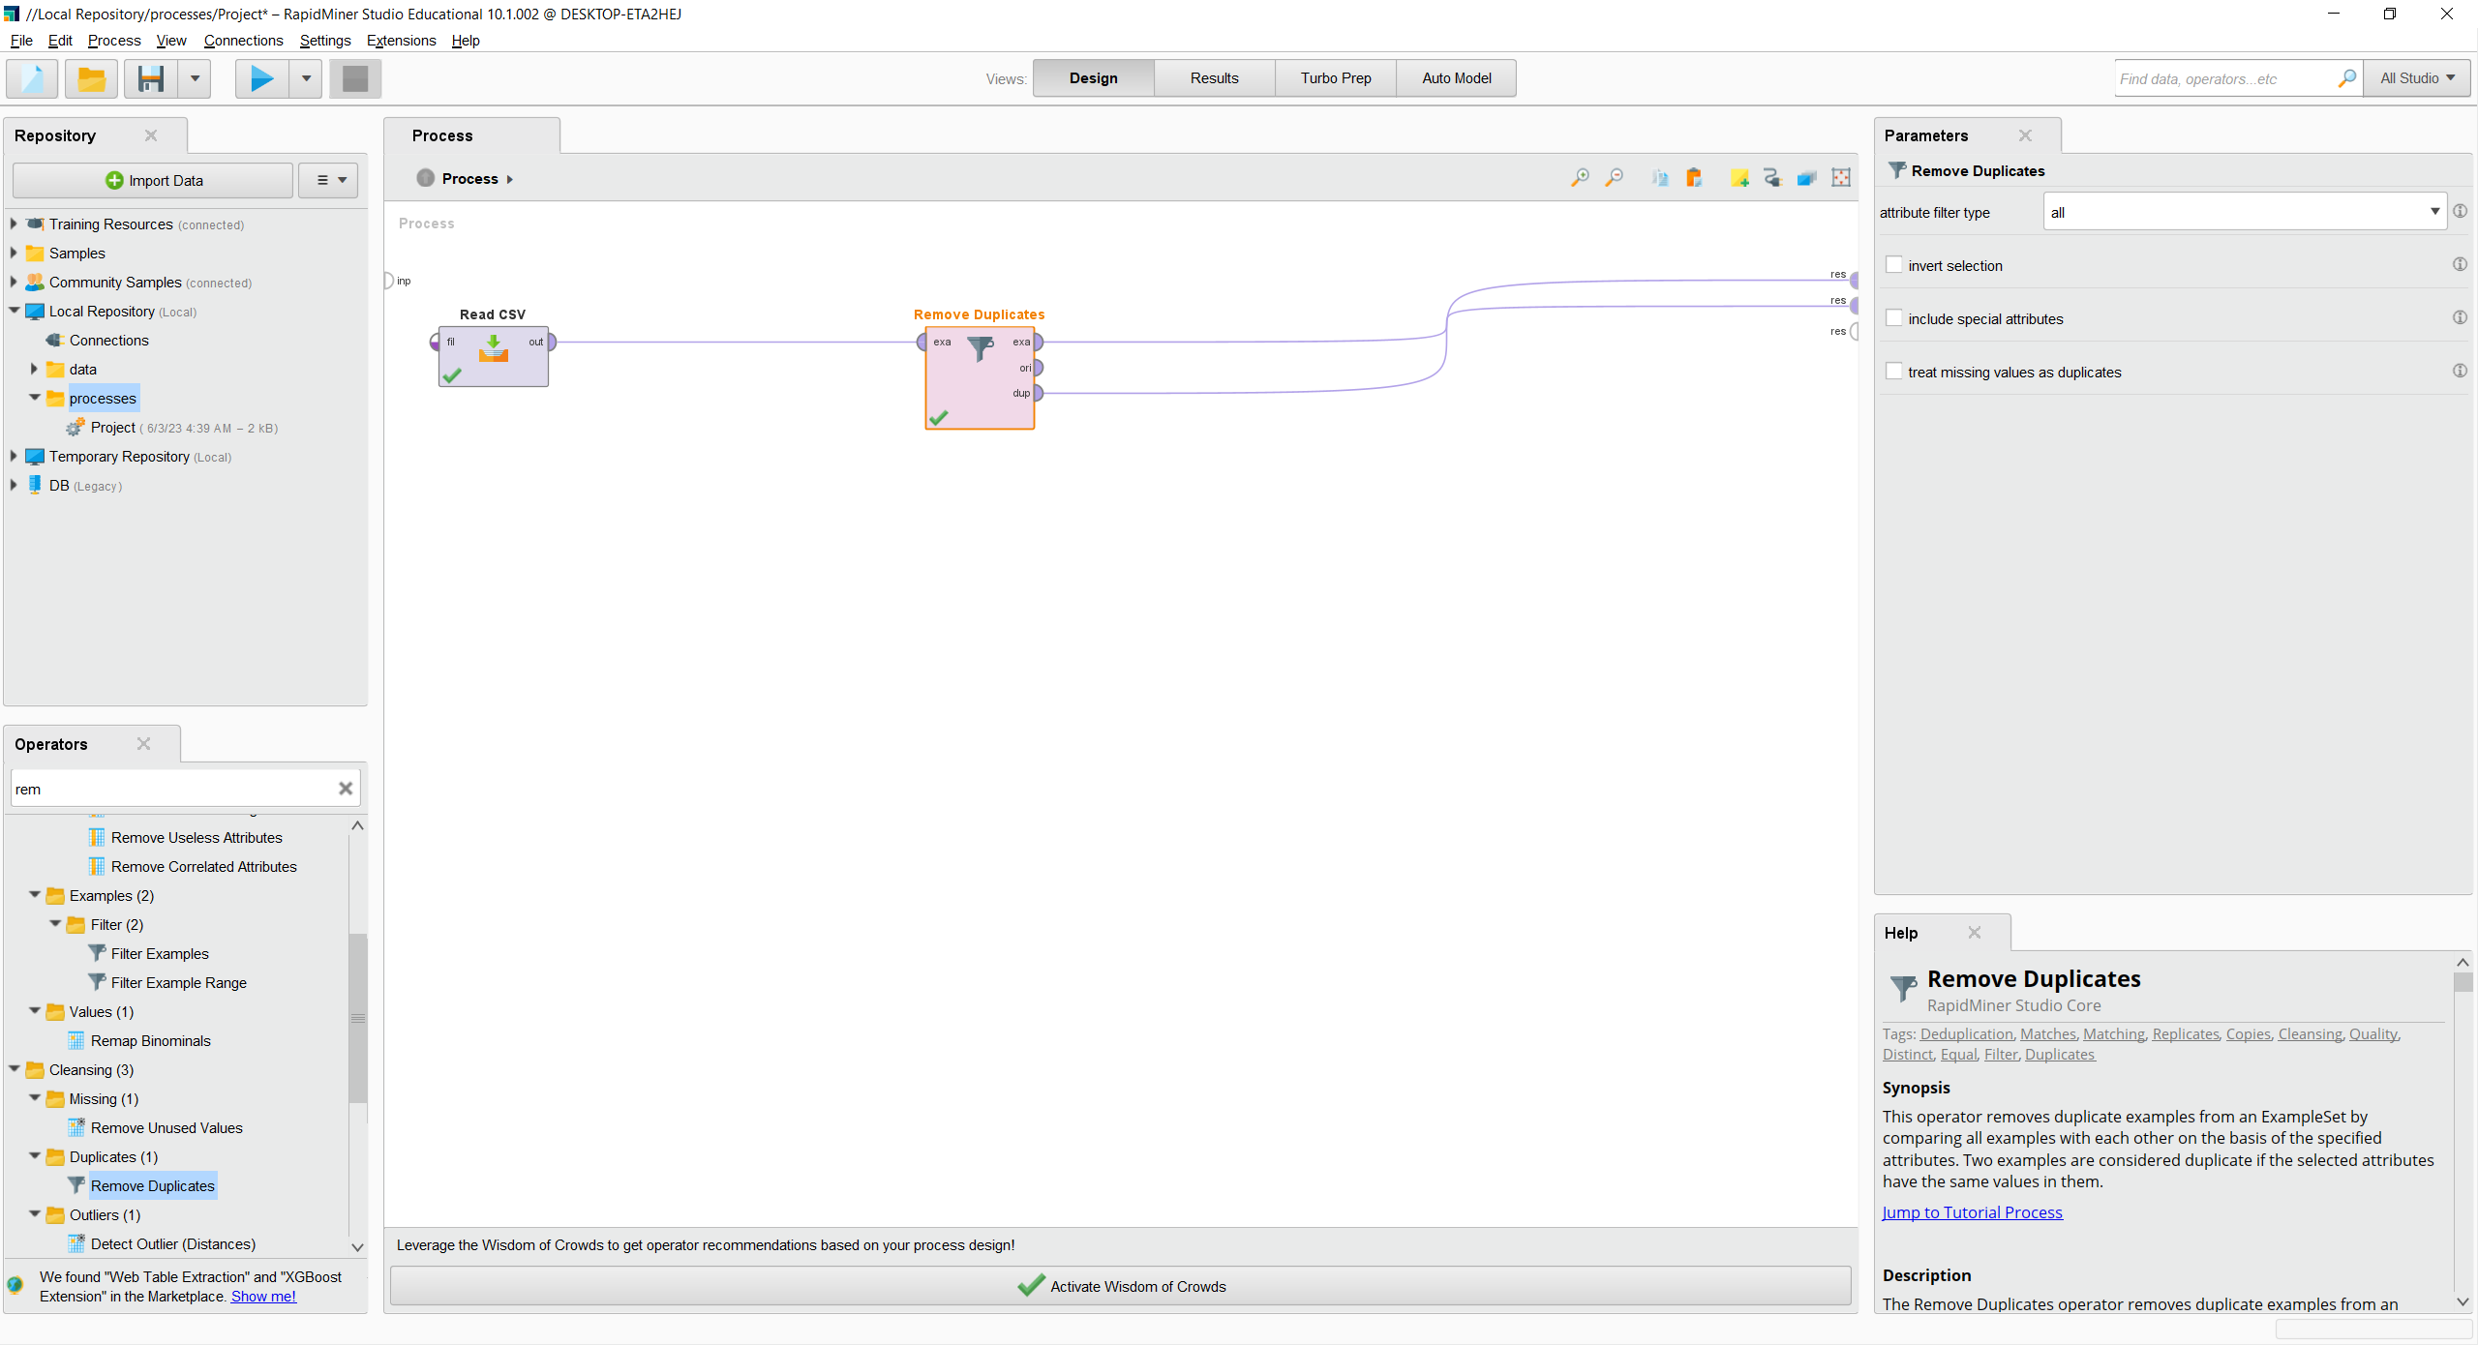

Removing duplicate using the "Remove duplicate" operator.

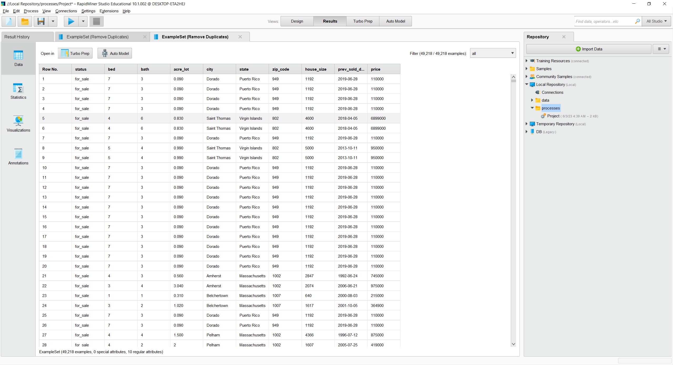

The number of redundant data examples is over 40k.

To try and understand more about our data set we will do a few visualizations one idea in mind was to see if number of bedrooms had any effect on the price of the house, so I created a plot to visualize that.

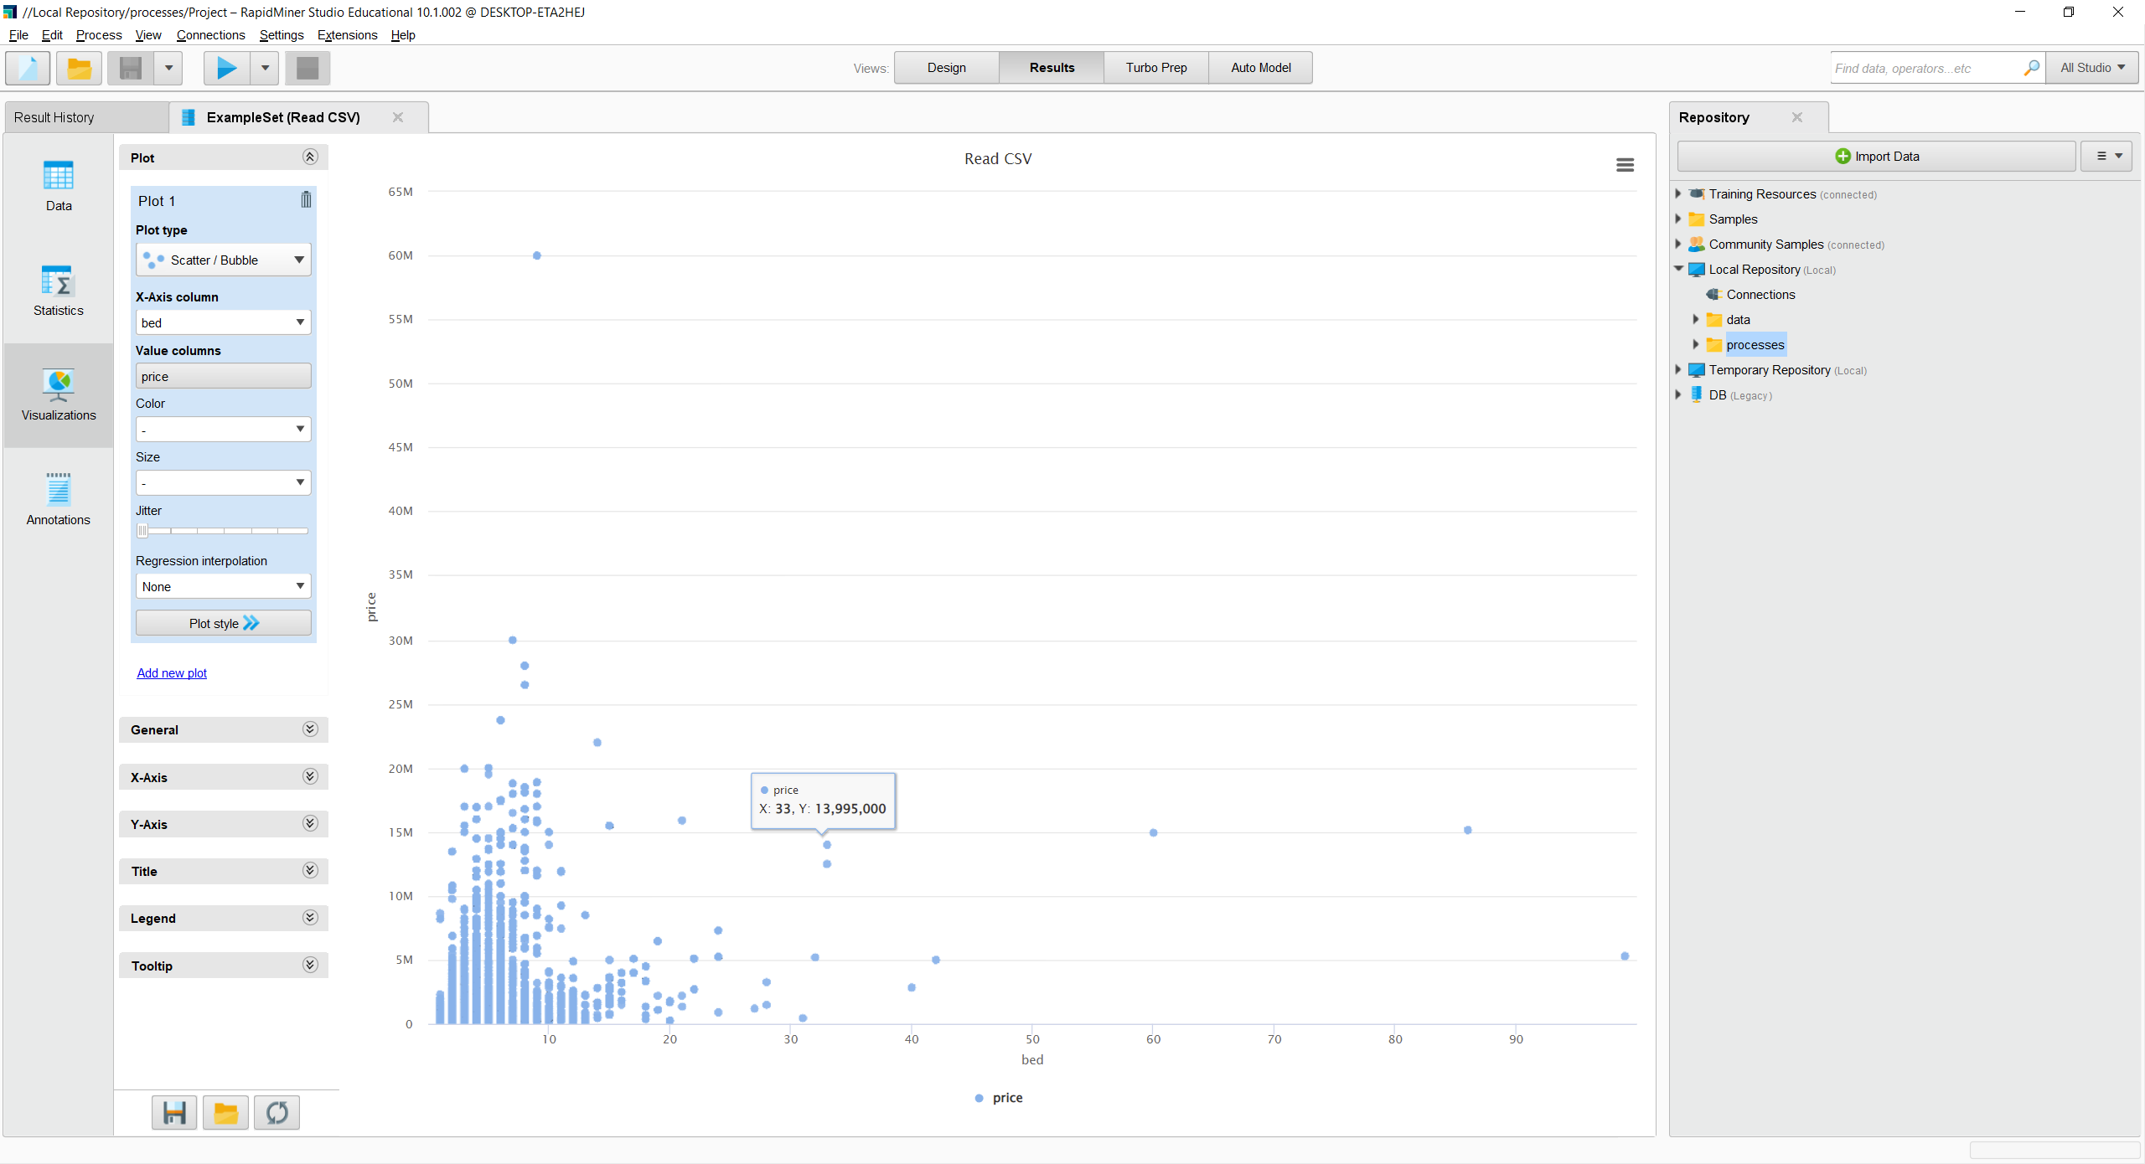

How much does the number of beds influence the price.

From this visualization we can see that to an extent the number of beds does influence the price of the house but there is probably a need to involve many more attributes to make our model more accurate.

One other check we wanted to do was how house location affected the house’s size as the house size is a big factor in buying and selling houses.

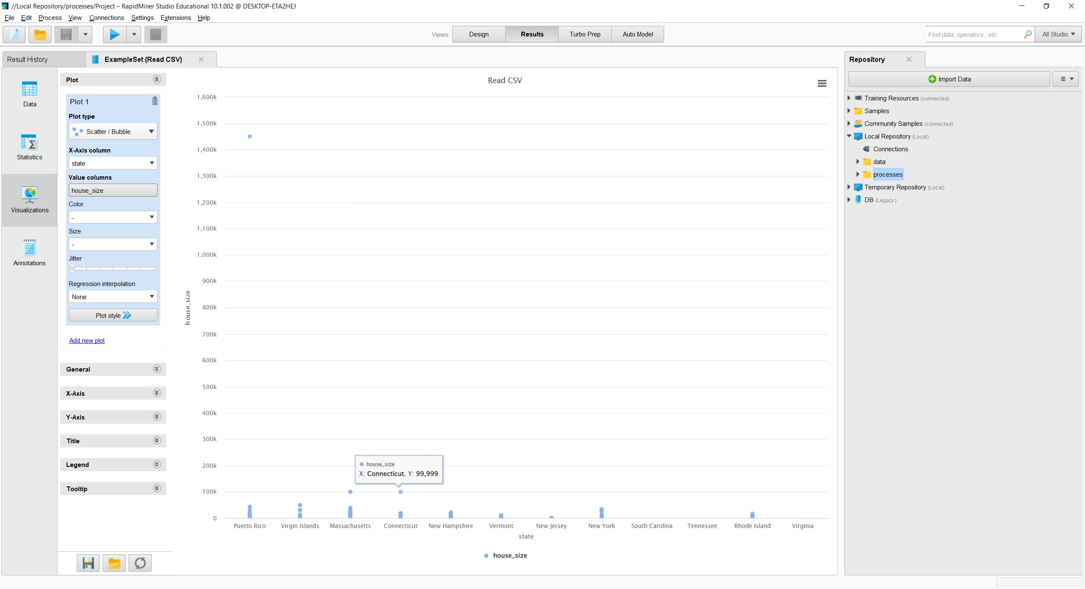

How house location affected the house’s size.

* After creating the plot, we can clearly see that there is a big difference in house sizes between all the various states. Which does make the data set varied enough to make any kind of predictor that we need and especially the predictor which we will be doing in this project.

# **Task 3**

Before we start building our models, we have a few steps to take. Look at the following diagram to realize our next steps.

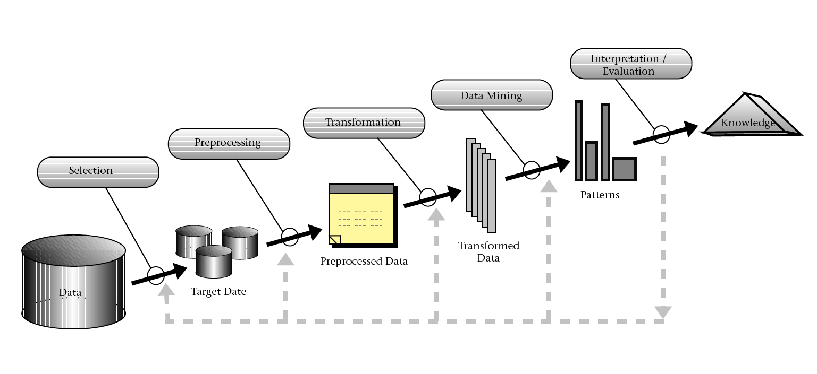

Since we have finished our first step, which is the selection of our data set before we start our Data Mining, we need to do the most important step which is preprocessing and transformation of our current data.

Our first step in the pre-processing phase is to handle our missing values. When we identified our attributes in the previous phase, we saw that we had some attributes that had missing values and so we should either replace them or in our case remove them. And so, we decided to replace them using the replace missing values operator. 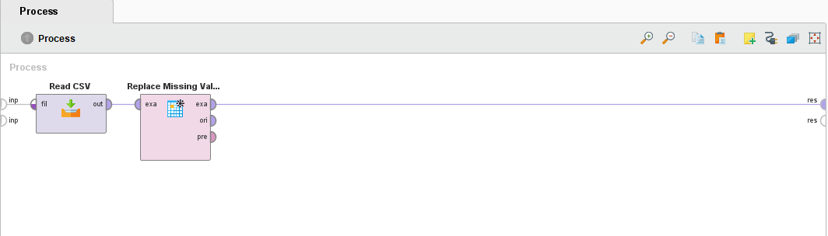

Replacing missing values using the "Replace missing value" operator.

And after running our process we can see the following.

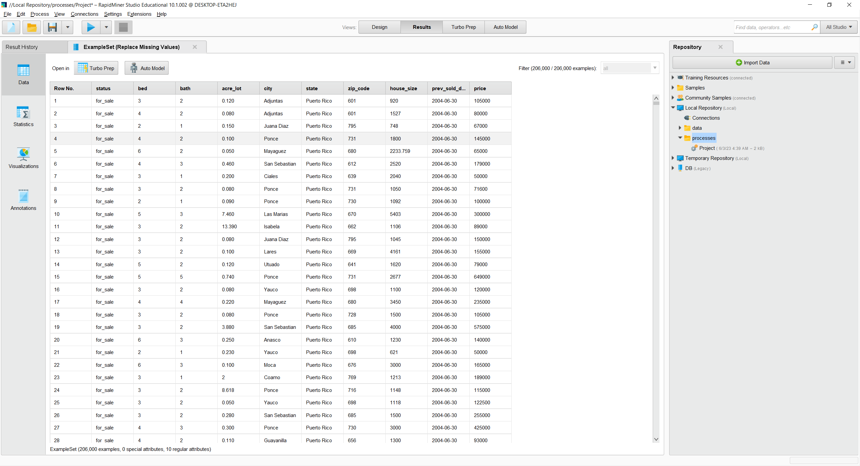

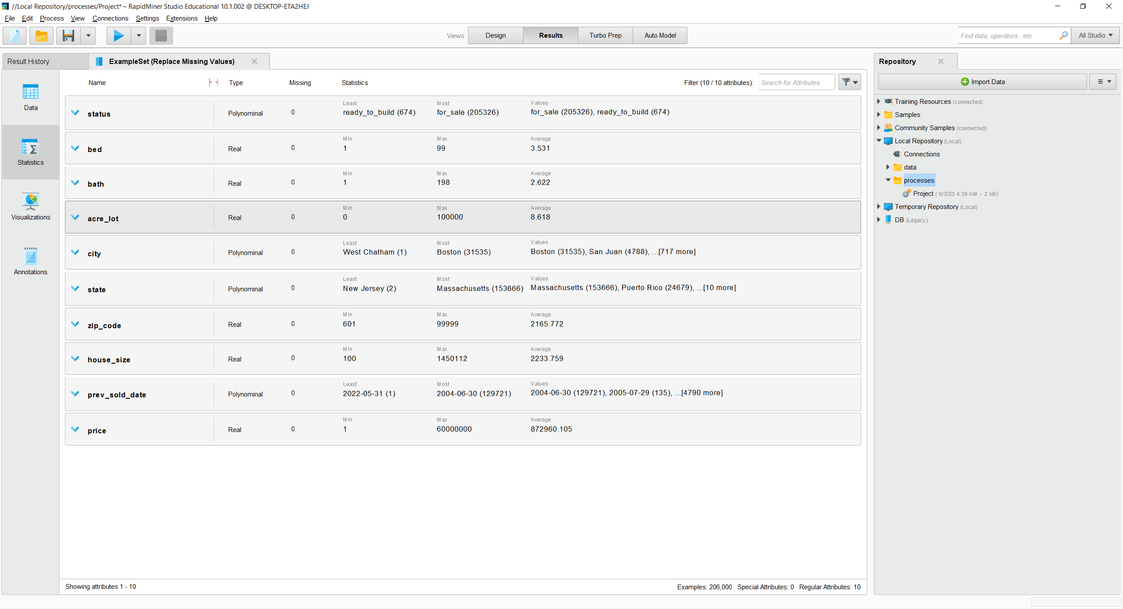

Replaced the missing values.

In the previous you can see that our number of missing attributes is 0. Now after replacing our missing attributes, we need to handle our repeated or redundant attributes which we will do using the remove duplicates modifier.

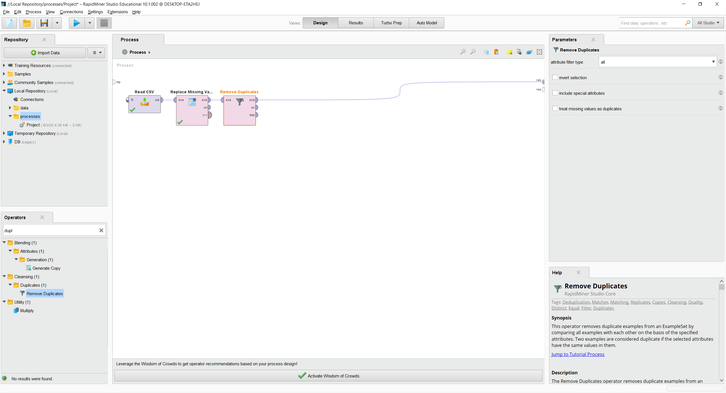

And after adding a breakpoint we can see the difference in our before and after deleting duplicate data.

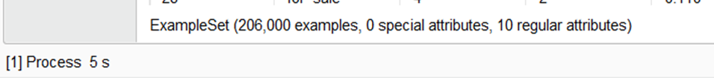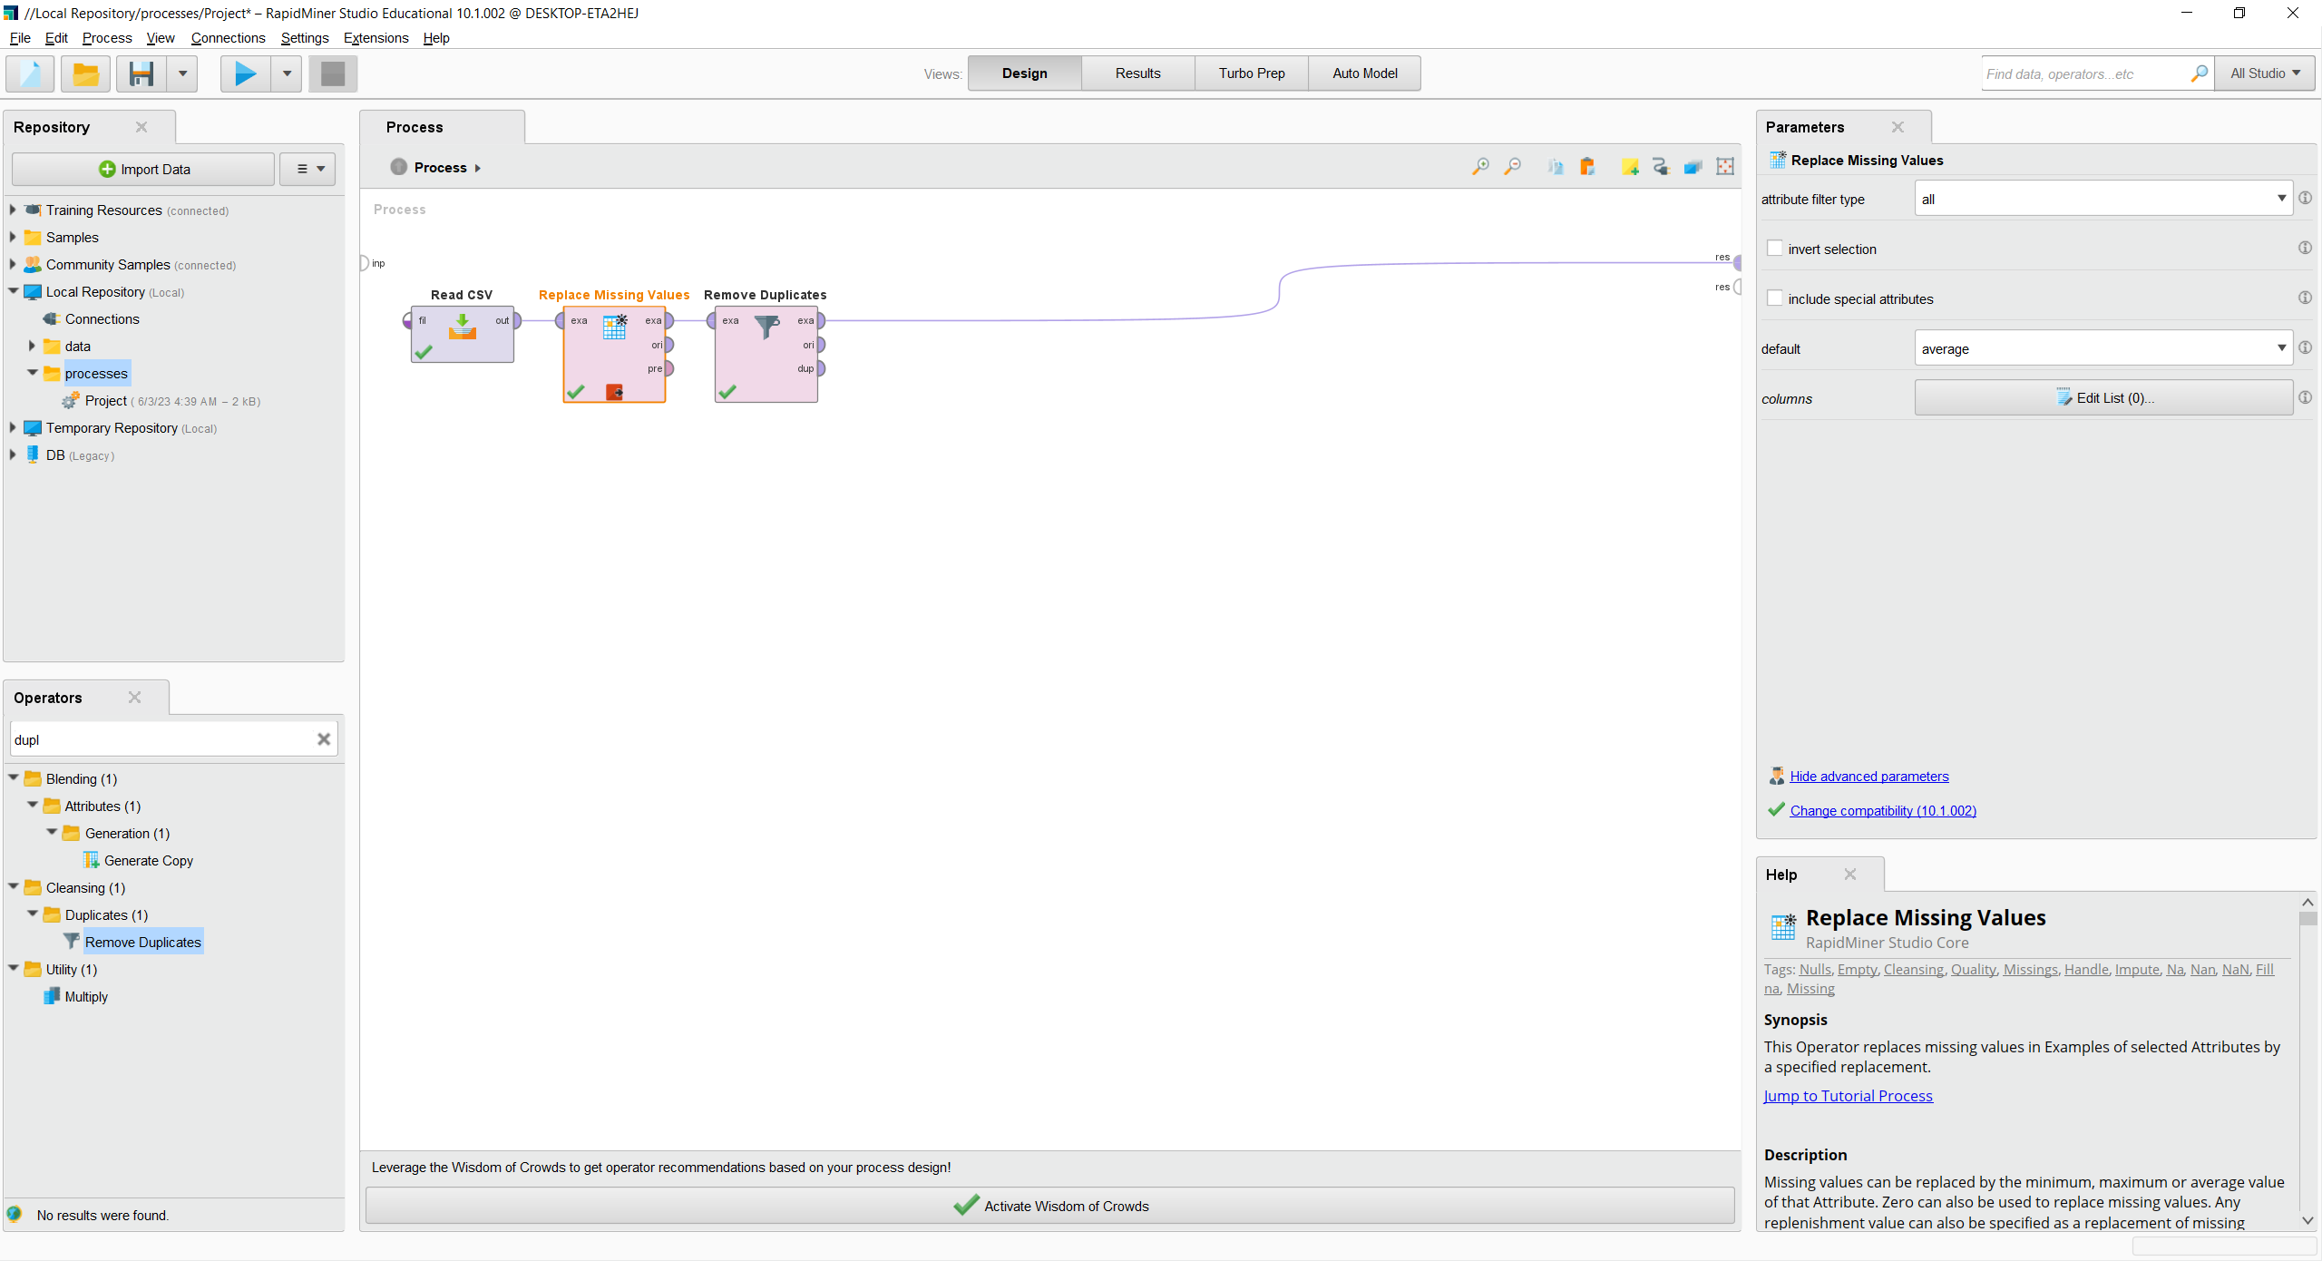

As you can see the number of our data was significantly reduced.

Now after the previous steps we can see from the following images that the range of certain attributes are quite high which makes the data much harder to read and visualize so our next step in preprocessing is going to be normalizing our data.

We will normalize a subset of acre_lot, house_size since they tend to be the attributes with the highest range. We will not normalize the price since we will use it as a label in our prediction later and we intend to maintain the original value.

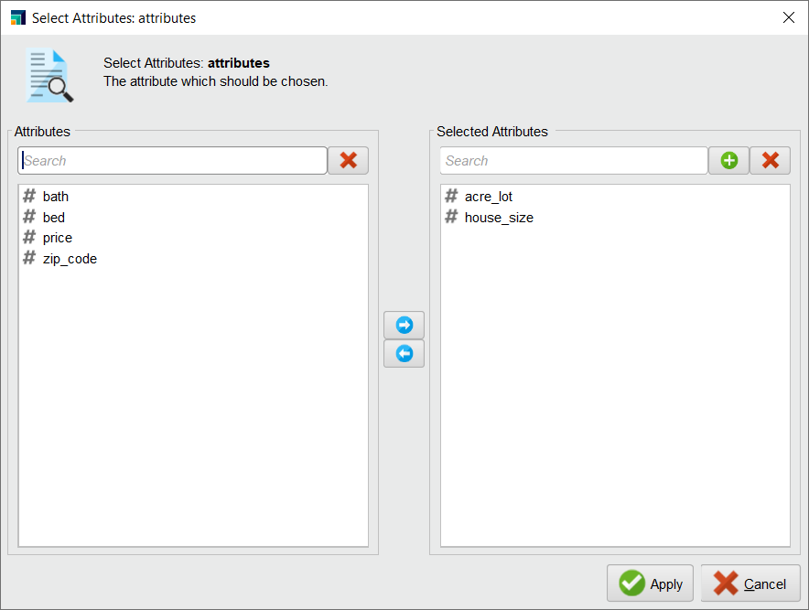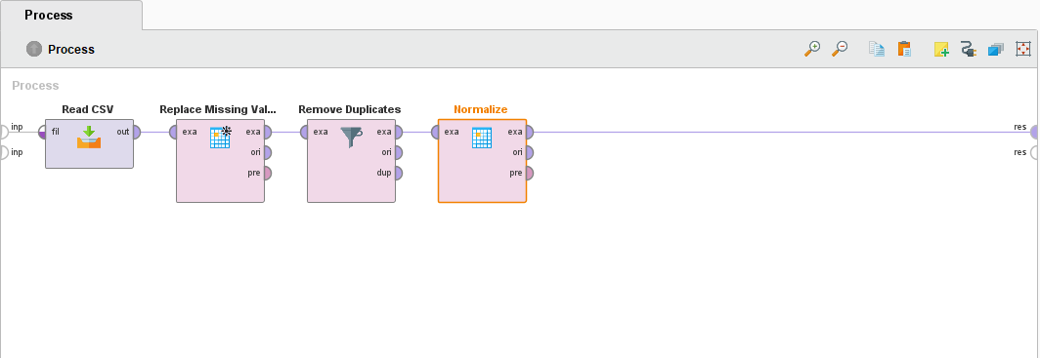

Normalizing the dataset subset using the "Normalize” operator.

Now after we run our process we can see the following.

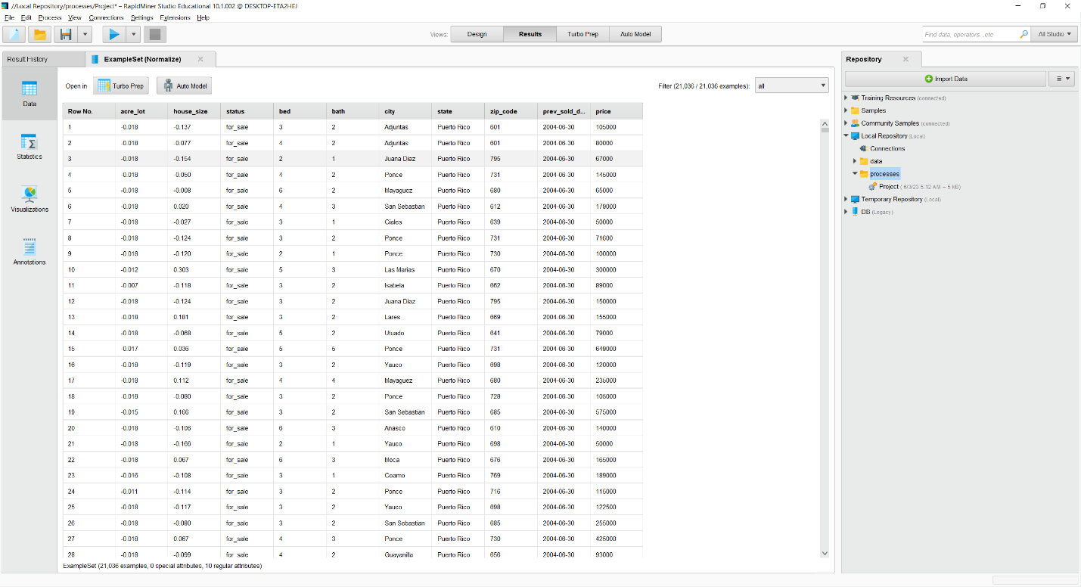

Dataset after normalizing

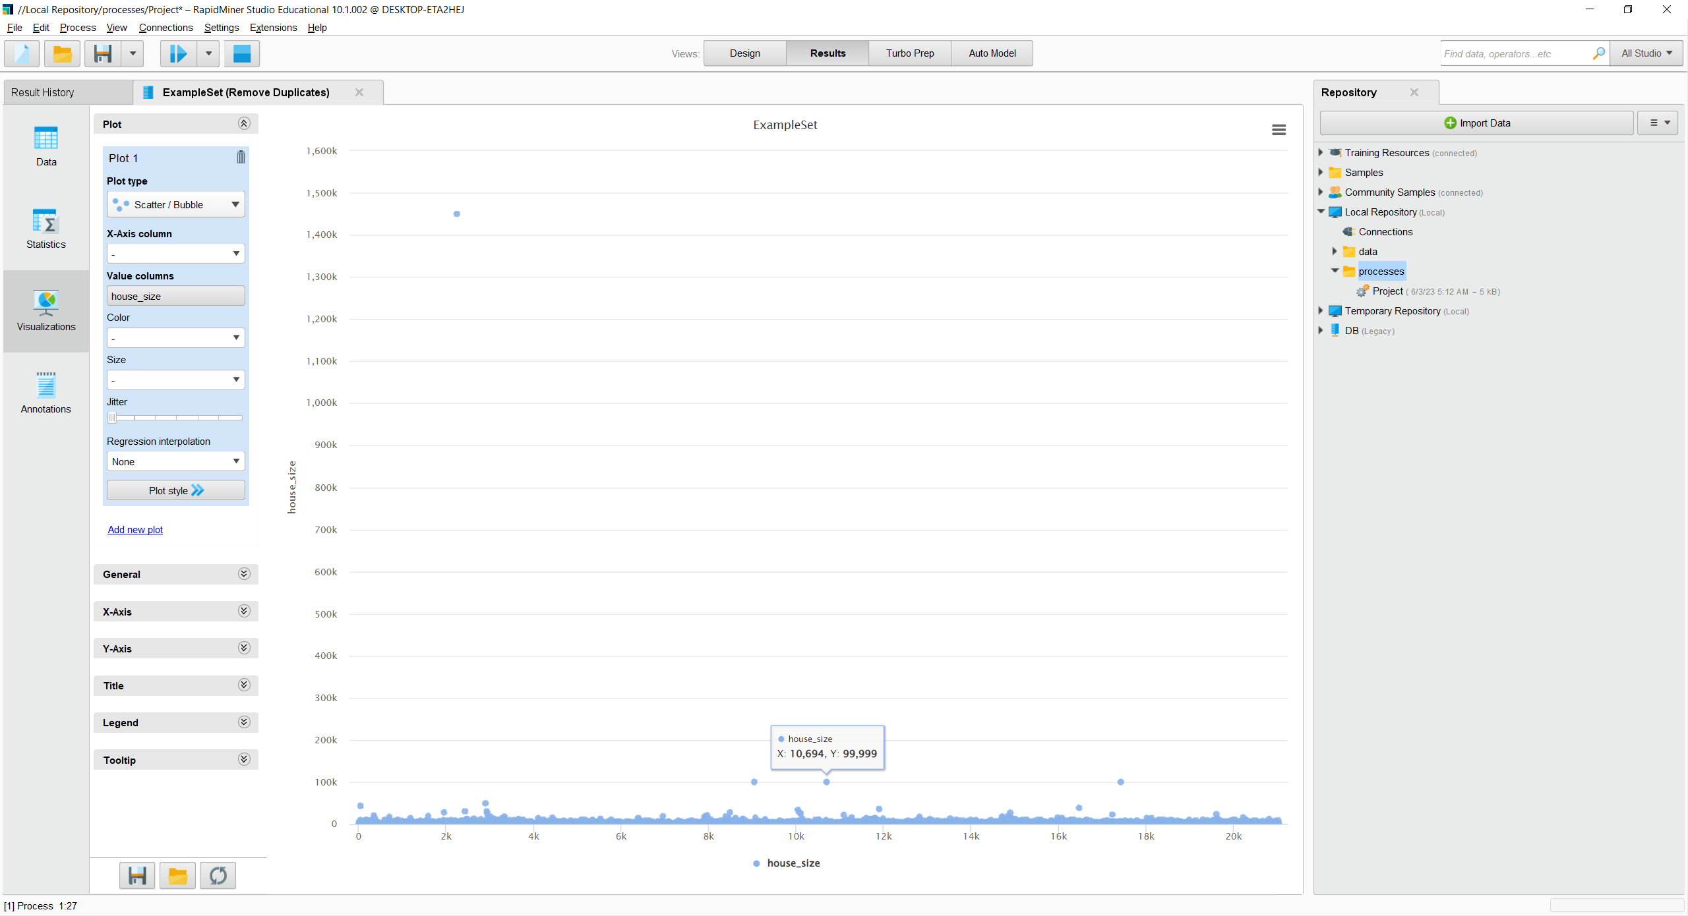

It can be seen in the y-axis that the range is in thousands.

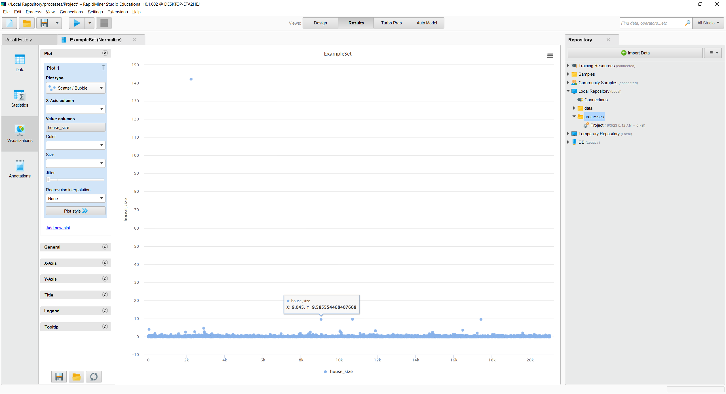

Now the y-axis range is less.

We can see how after normalizing our data goes from thousands to a much smaller range.

Now after normalizing our data, we can see in the above visualization that some points seem to be much further away from others and these points are our outliers. Since these outliers can heavily influence the accuracy of our model it is best to remove them with the first using the detect outliers modifier.

However, before using the detect outlier’s modifier we need to reduce our sample size, our dataset has thousands of entries and using such a huge sample size takes a long time to run. So, we will use the sample modifier to create a sample size of 2000 entries.

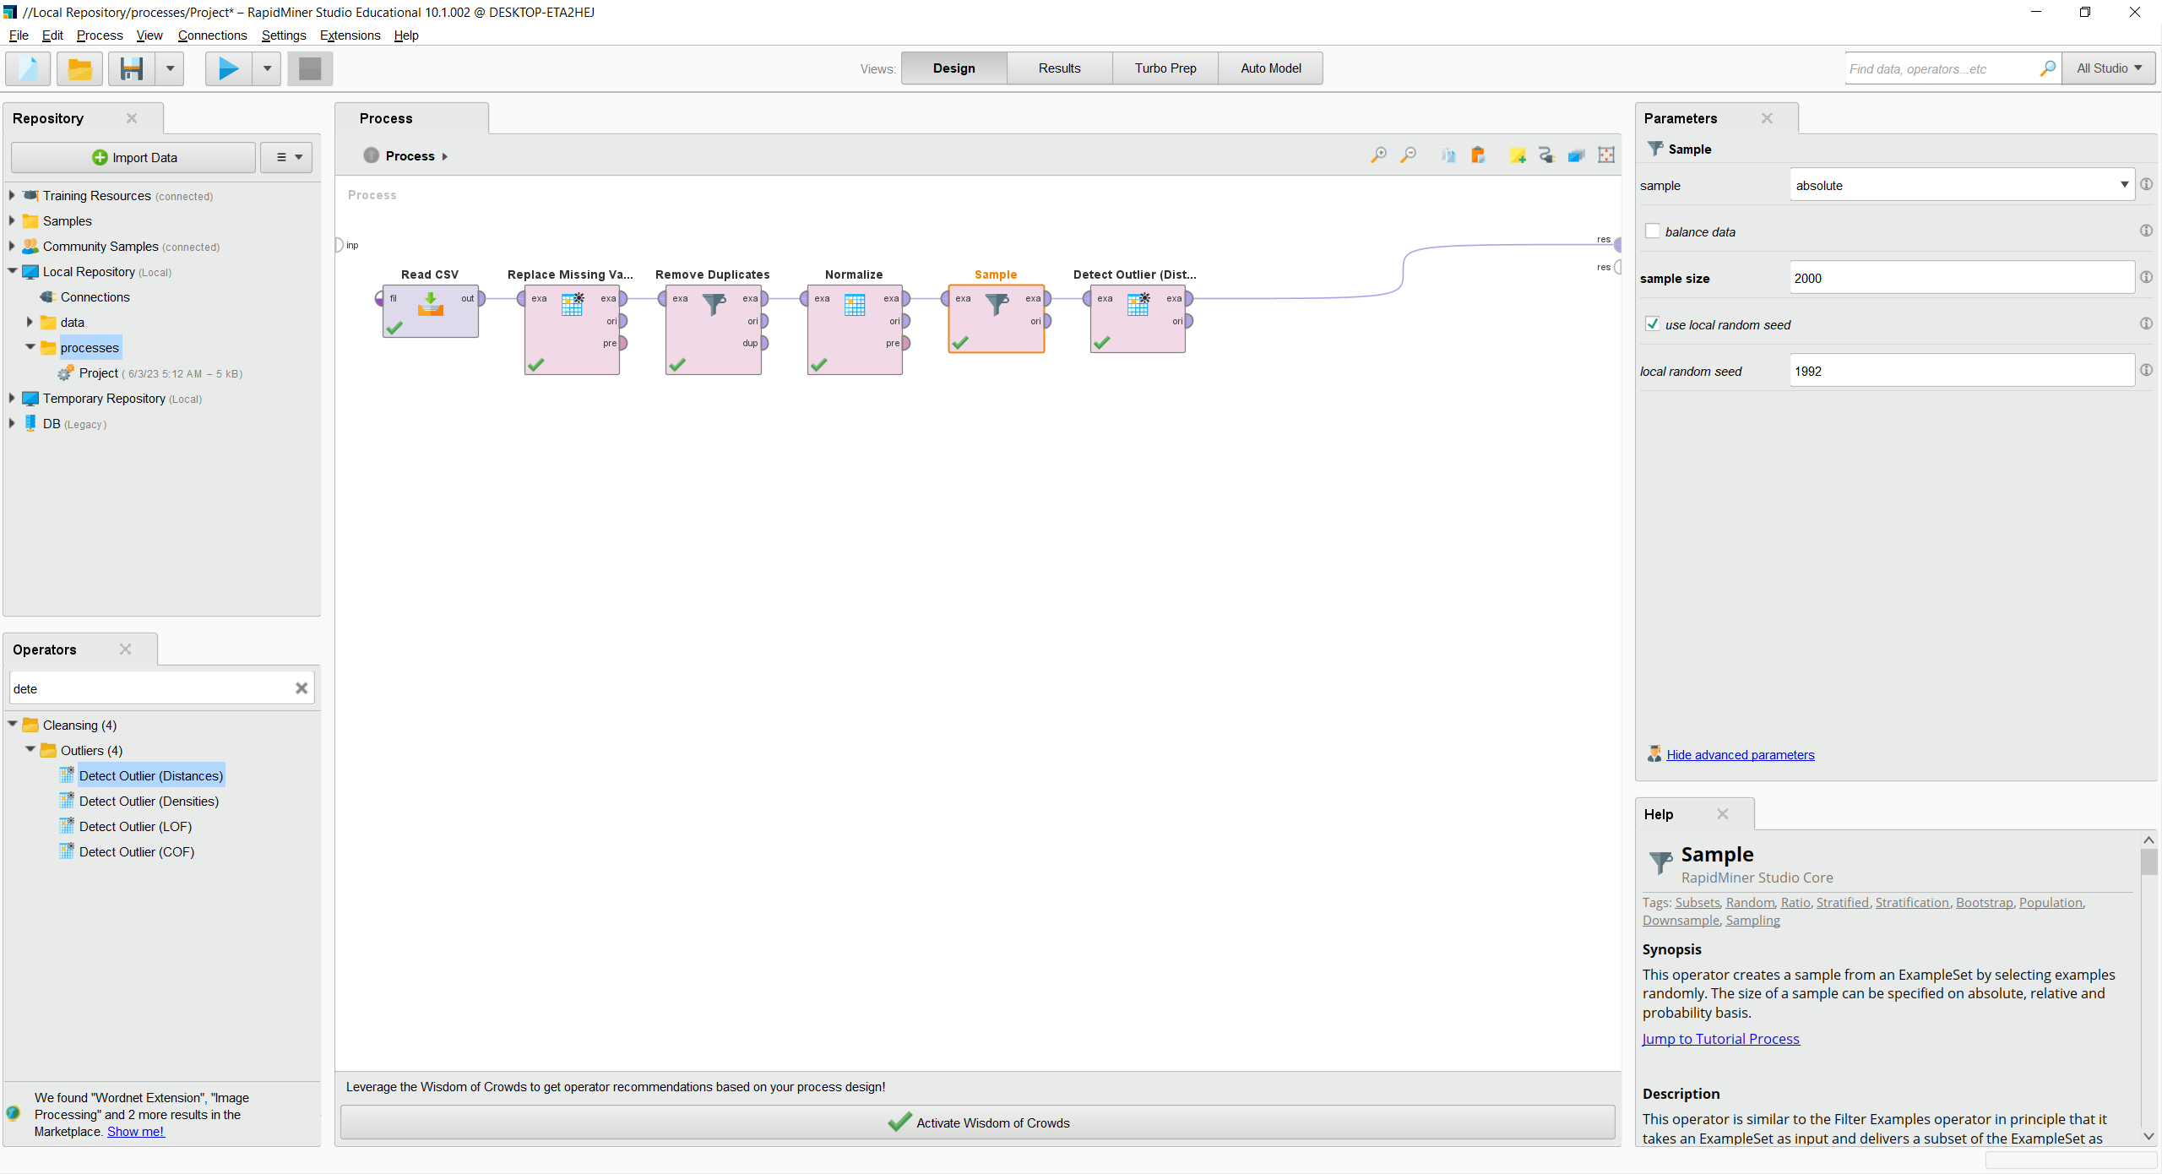

Now after reducing our sample size, we will detect our outliers.

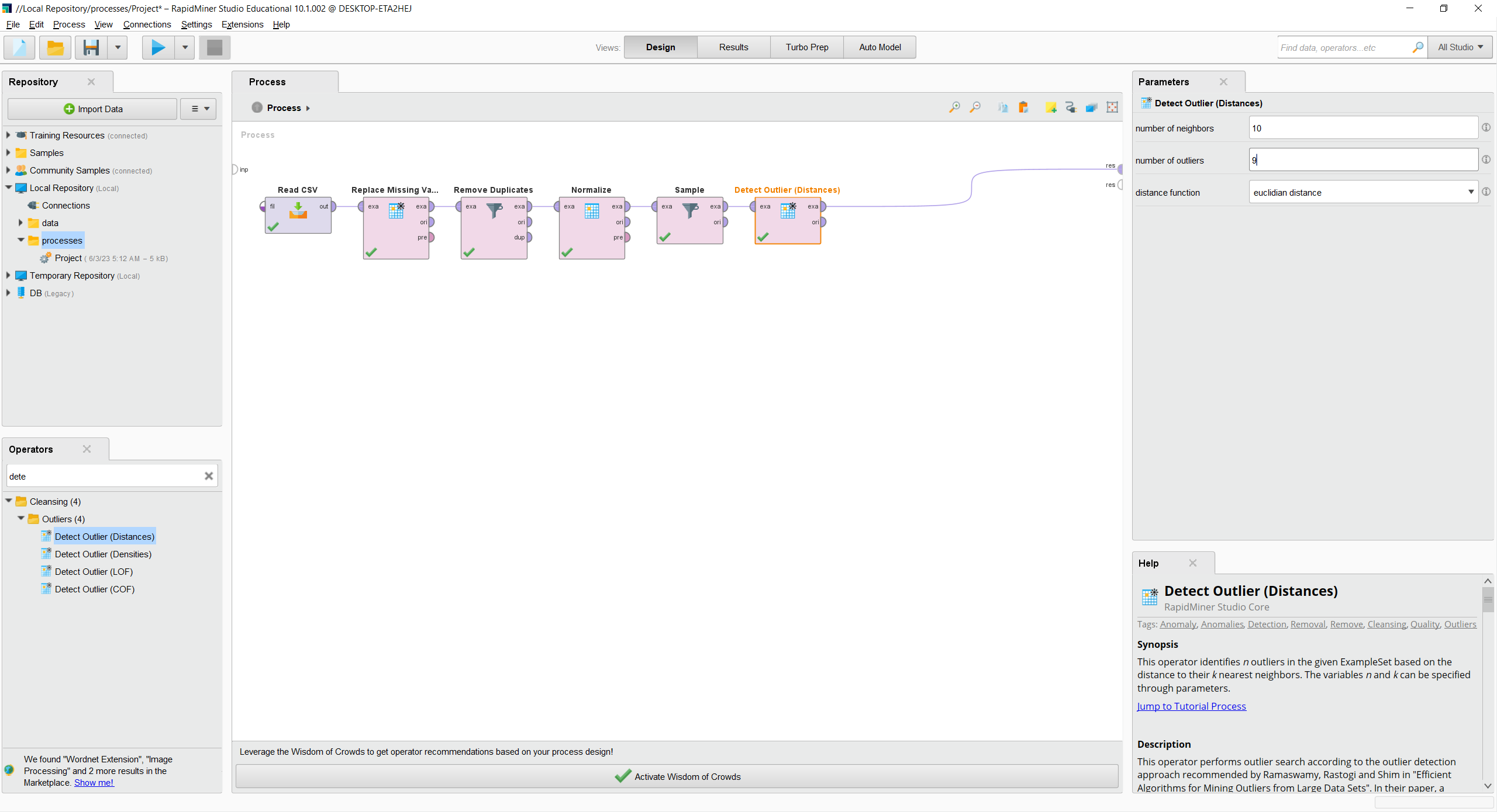

Finding out the outliers using "Detect outliers" operator.

Since we want our data to be accurate we do not wish to remove many outliers only the ones that heavily skew our data. As you can see from the plot below there are some houses that are simply too expensive which is why we need to set them as outliers.

We have chosen to remove 9 outliers, and these are the outliers.

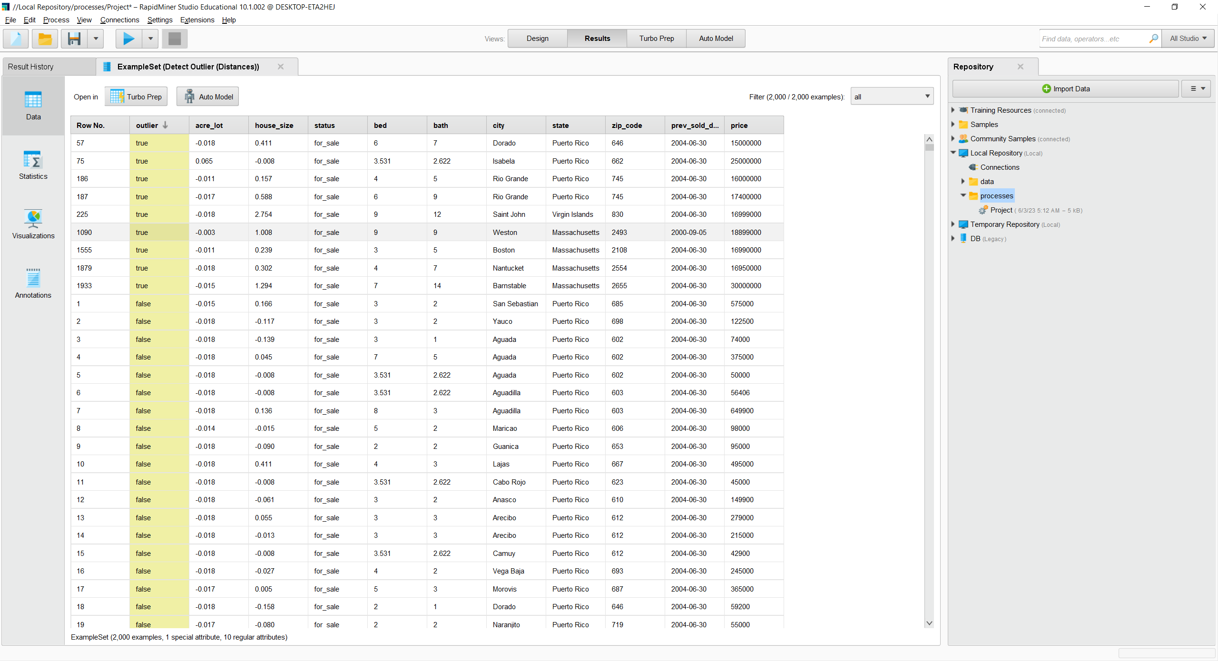

Now after detecting the outliers these are our plots before removing the outliers.

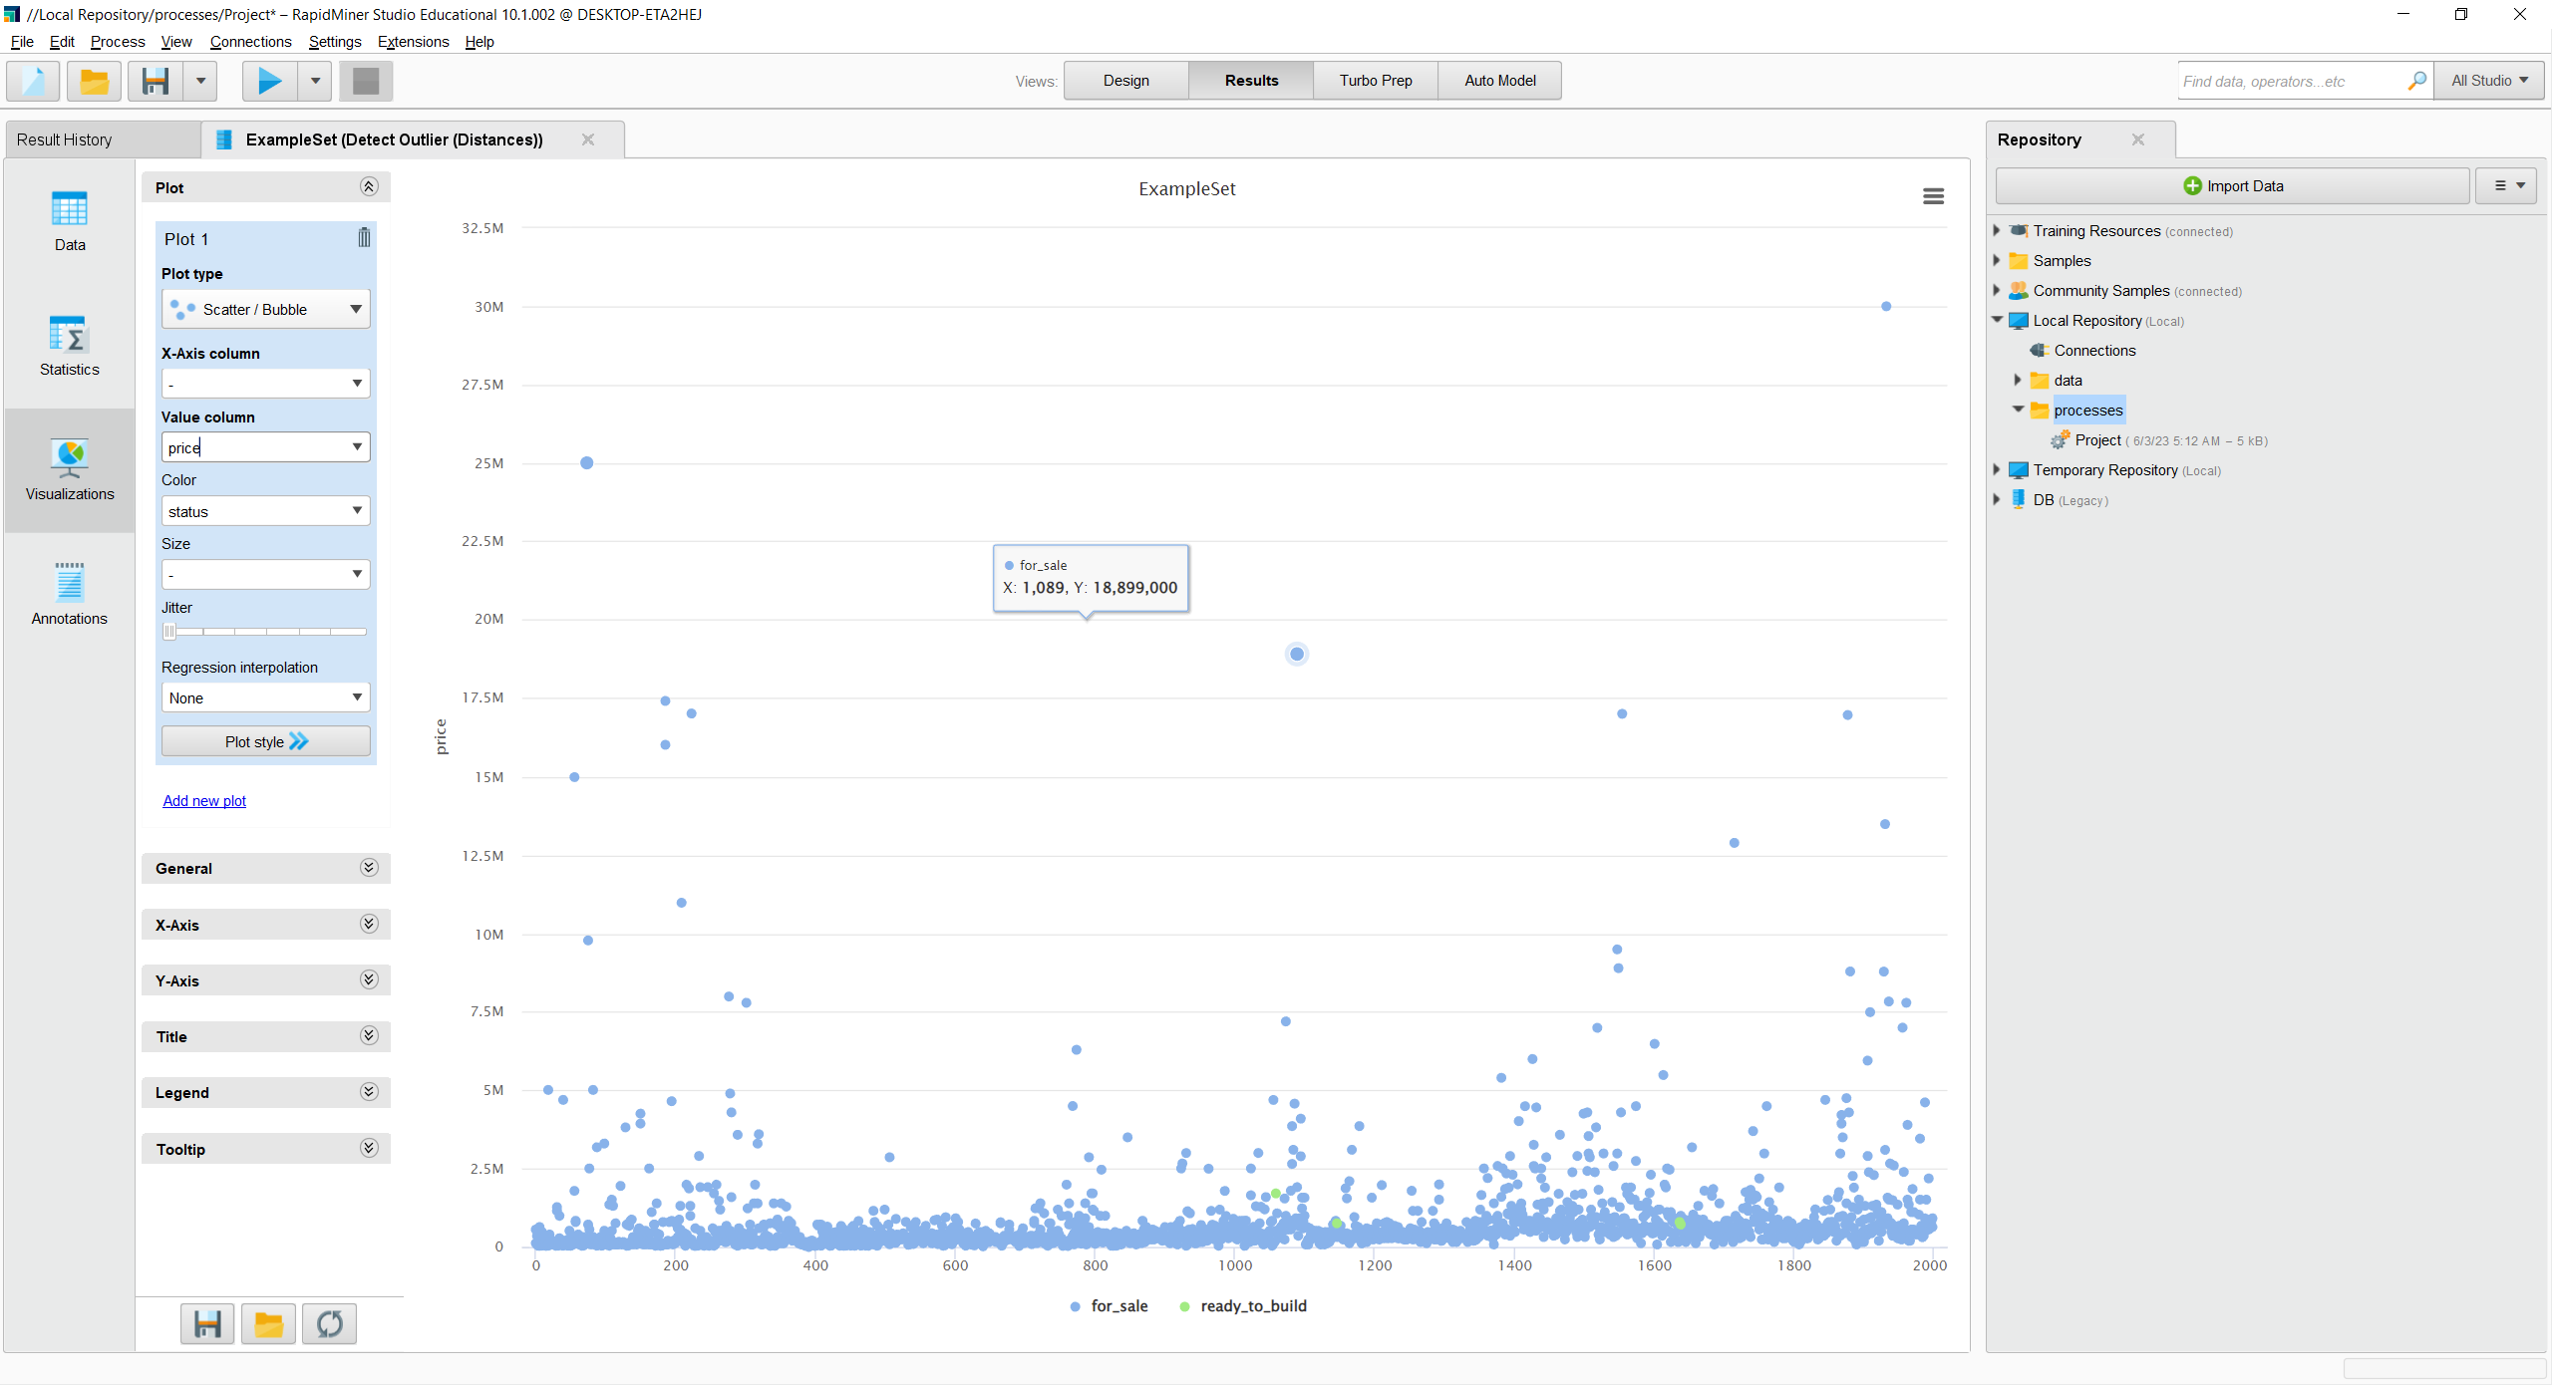

And then we will use a filter modifier to remove outliers.

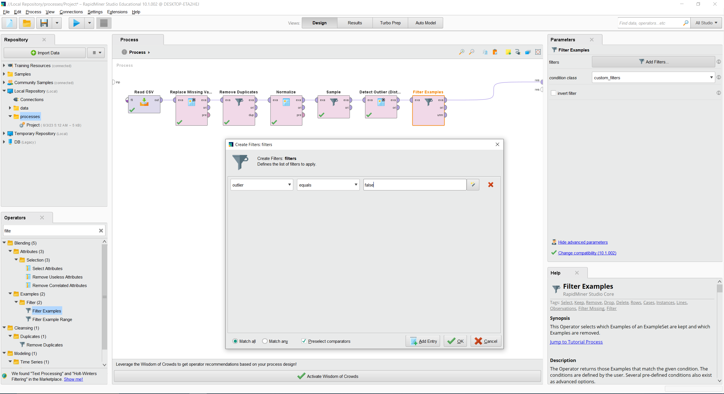

No this is our plot after removing the outliers.

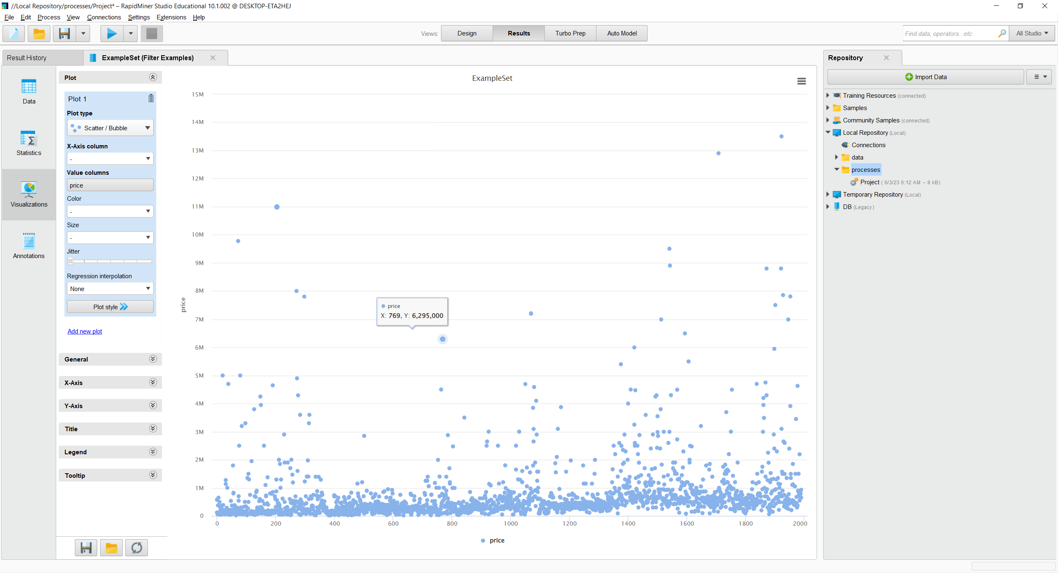

As you can see there are no longer house prices that are too far away from the normal range.

Now we need to reduce our current dimensions as we have too many attributes. We would usually use principal component analysis. However, we wish to keep our attribute names and we wish for our data to be easily interpretable so we will instead remove some attributes which we believe might not be needed for our final model.

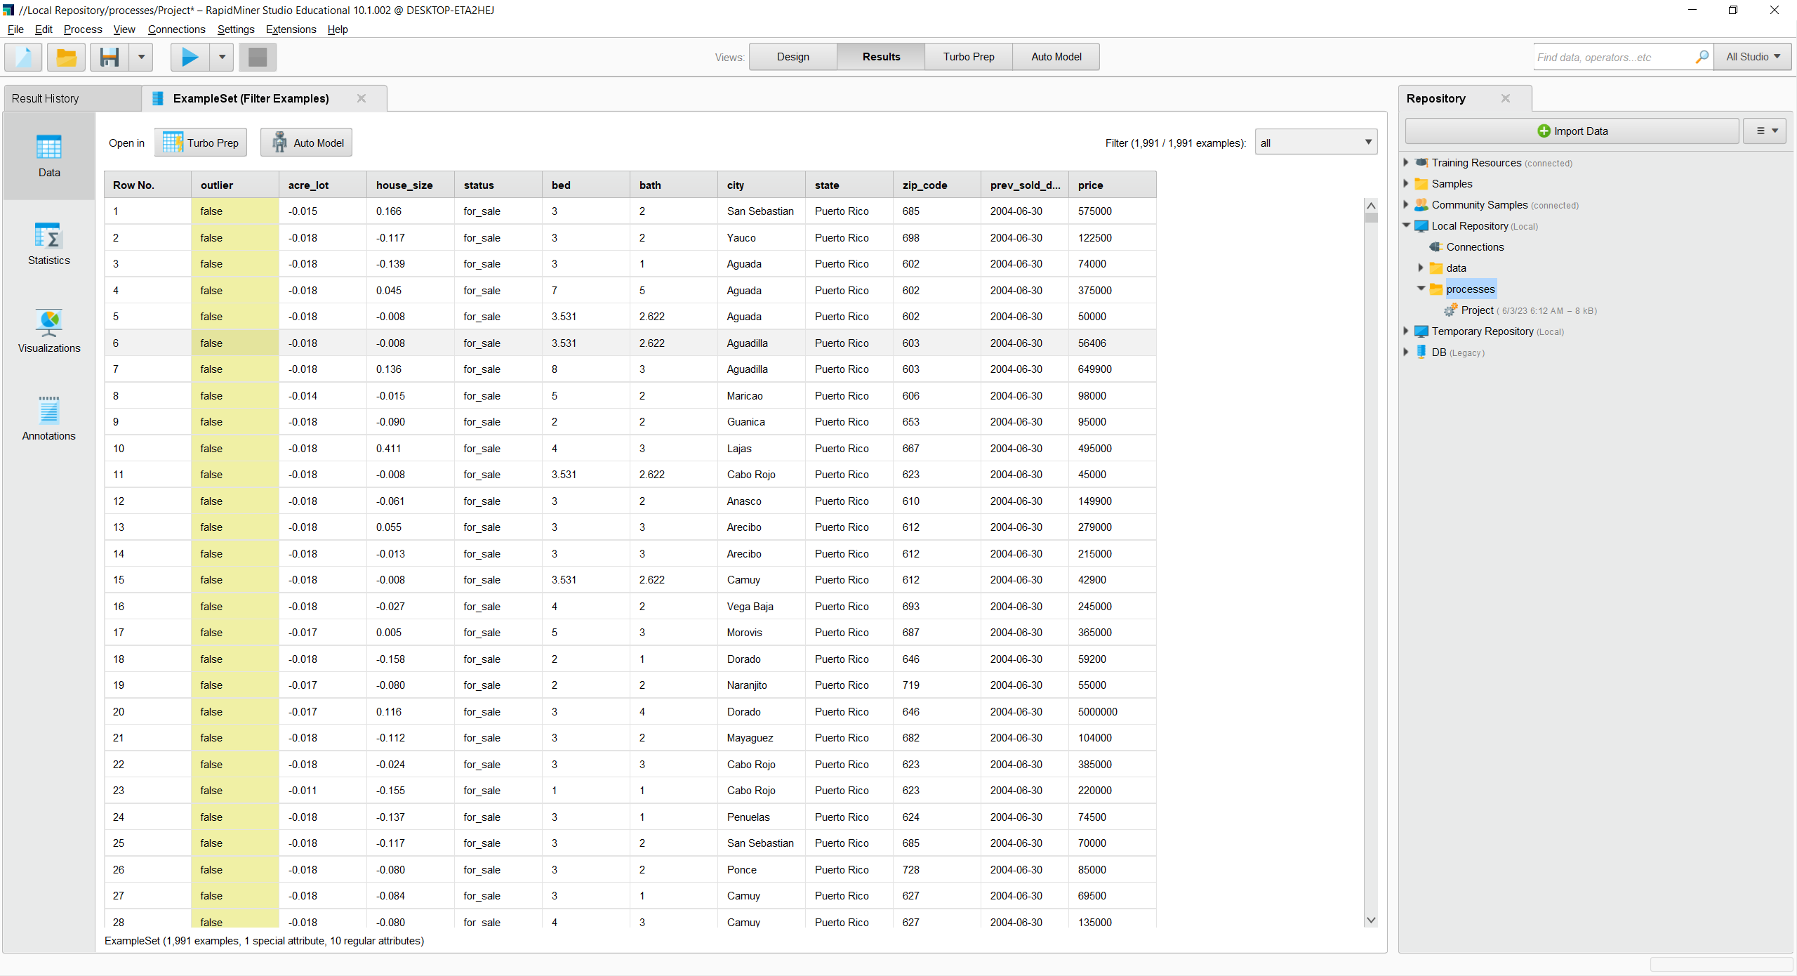

From our data we can see that city, state and zip code are all attributes which are related to location. Since zip-code is the most specific we will be keeping it while removing the other two. We also have already filtered our outliers out, so we don’t need the outlier attribute. Moreover, the status of the house currently also does not matter in our final model so it will be the final attribute we remove.

Now using the select attribute modifier to exclude attributes we exclude the following.

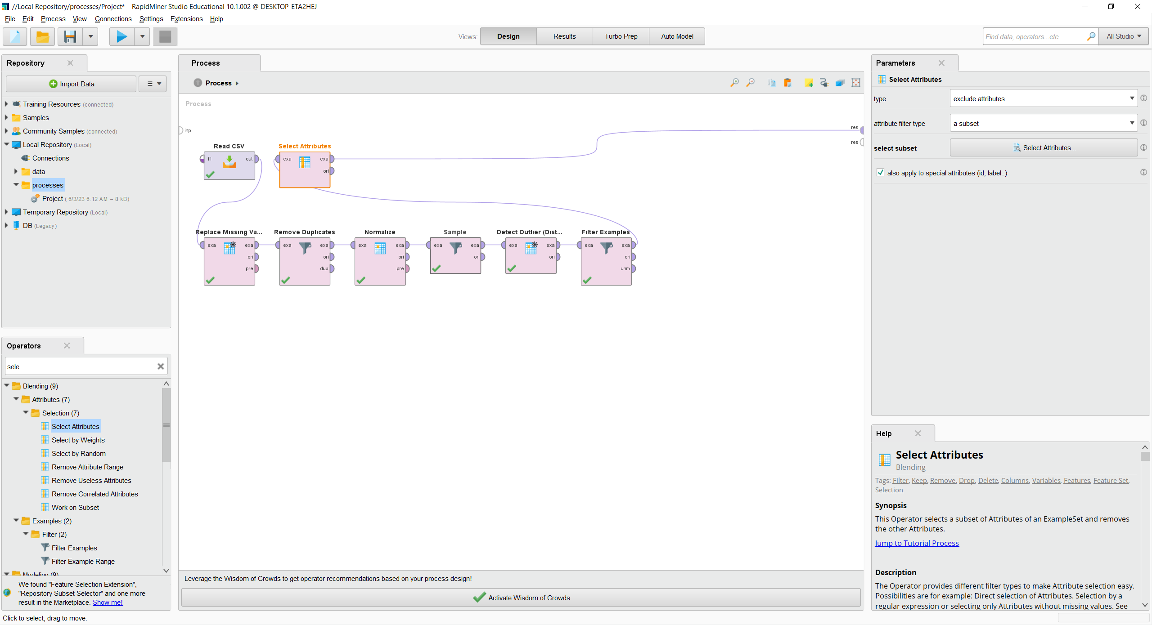

We use the select attribute operator to exclude attributes.

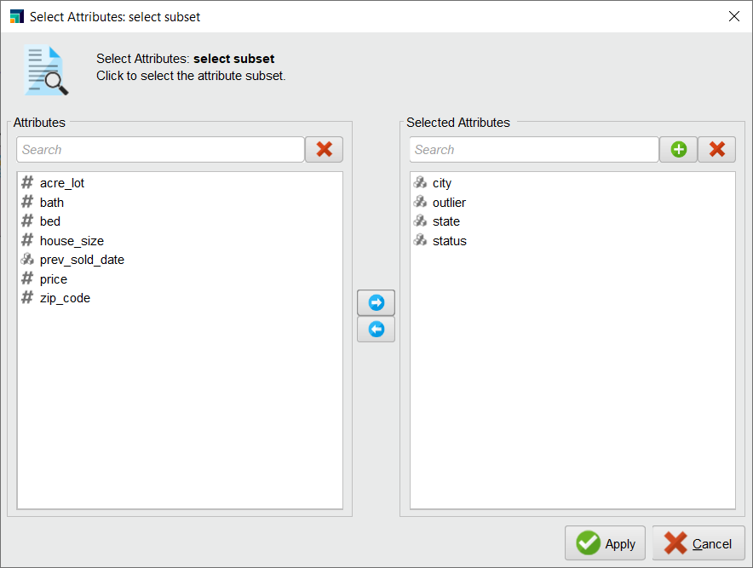

And as you can see we reduced the amount of our attributes and dimensions.

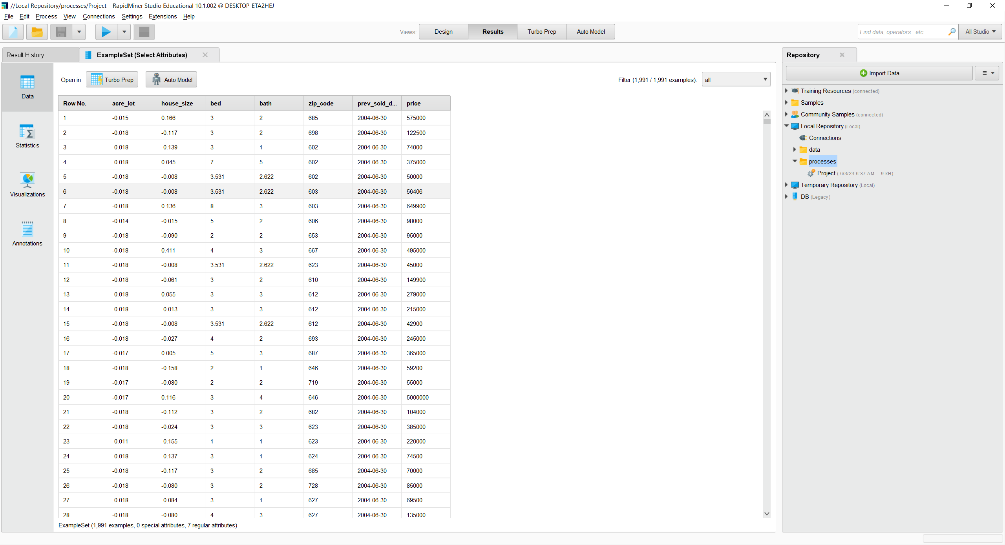

Now one other thing, if we go to our example data set, we can see that our previously sold date is considered a nominal value. Since we wish to use it as a variable in our model creation, we must change its type.

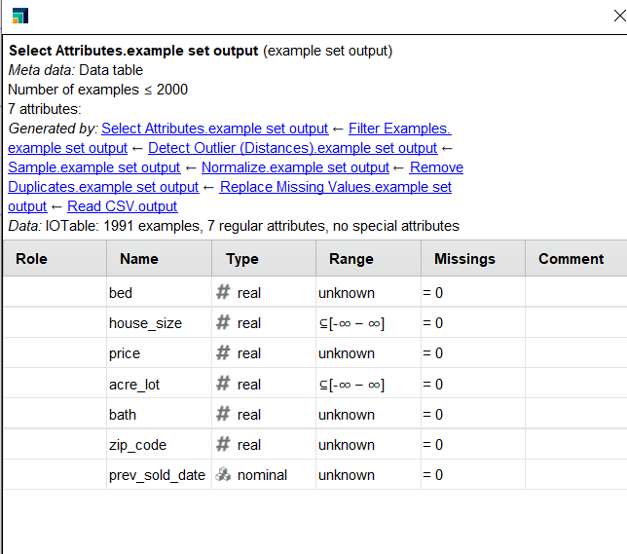

So, we will use the nominal to date modifier and change the type of the attribute.

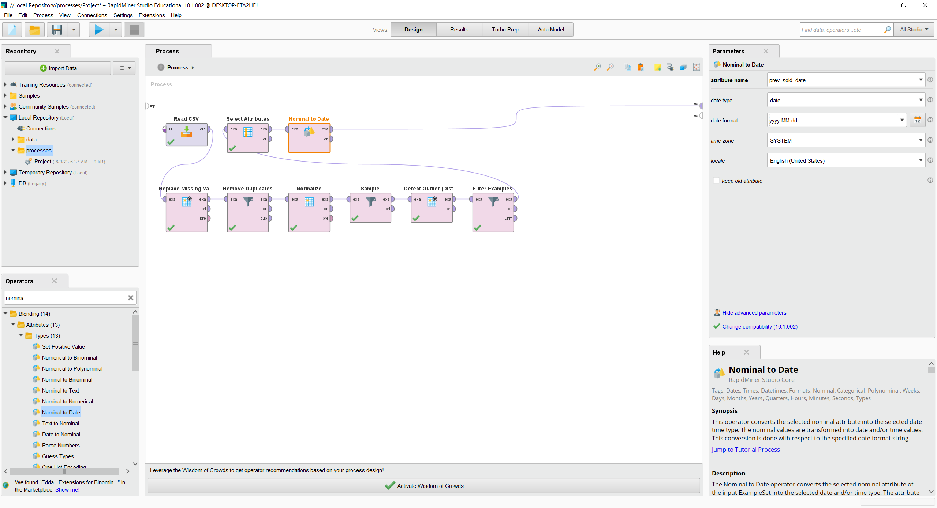

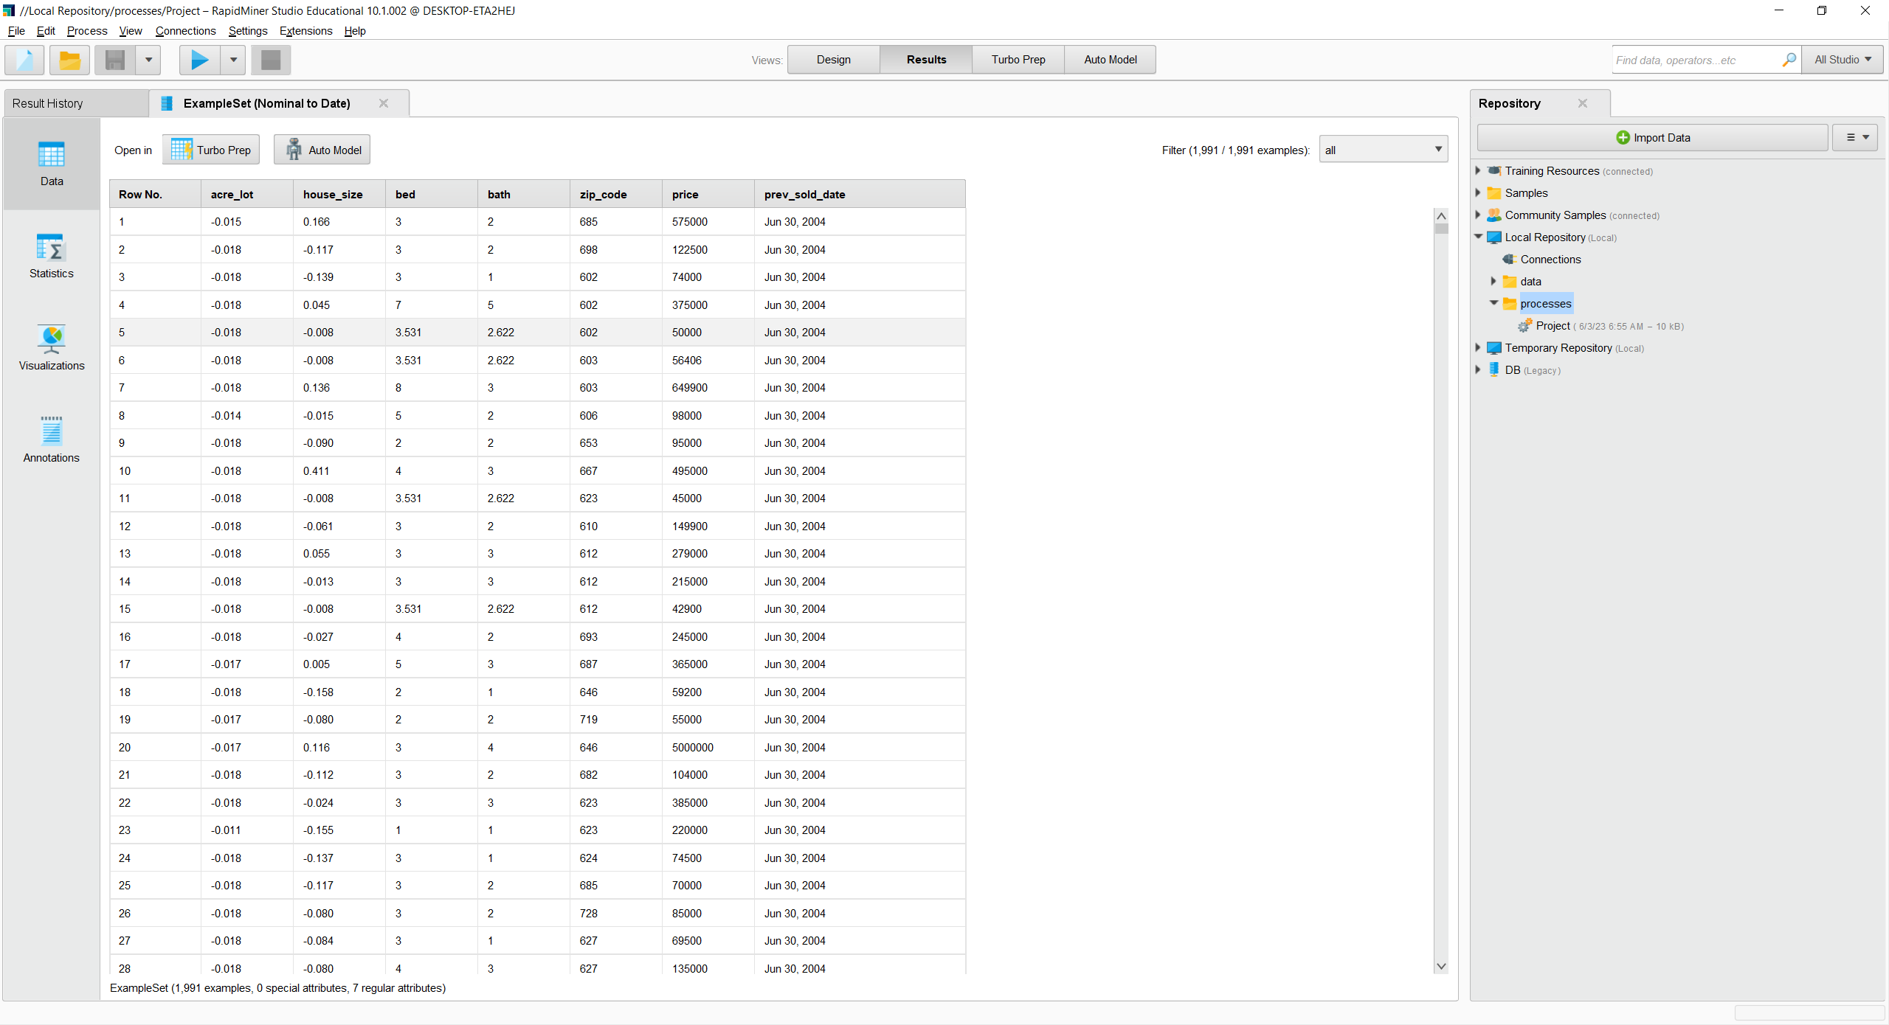Now as you can see our data type has changed.

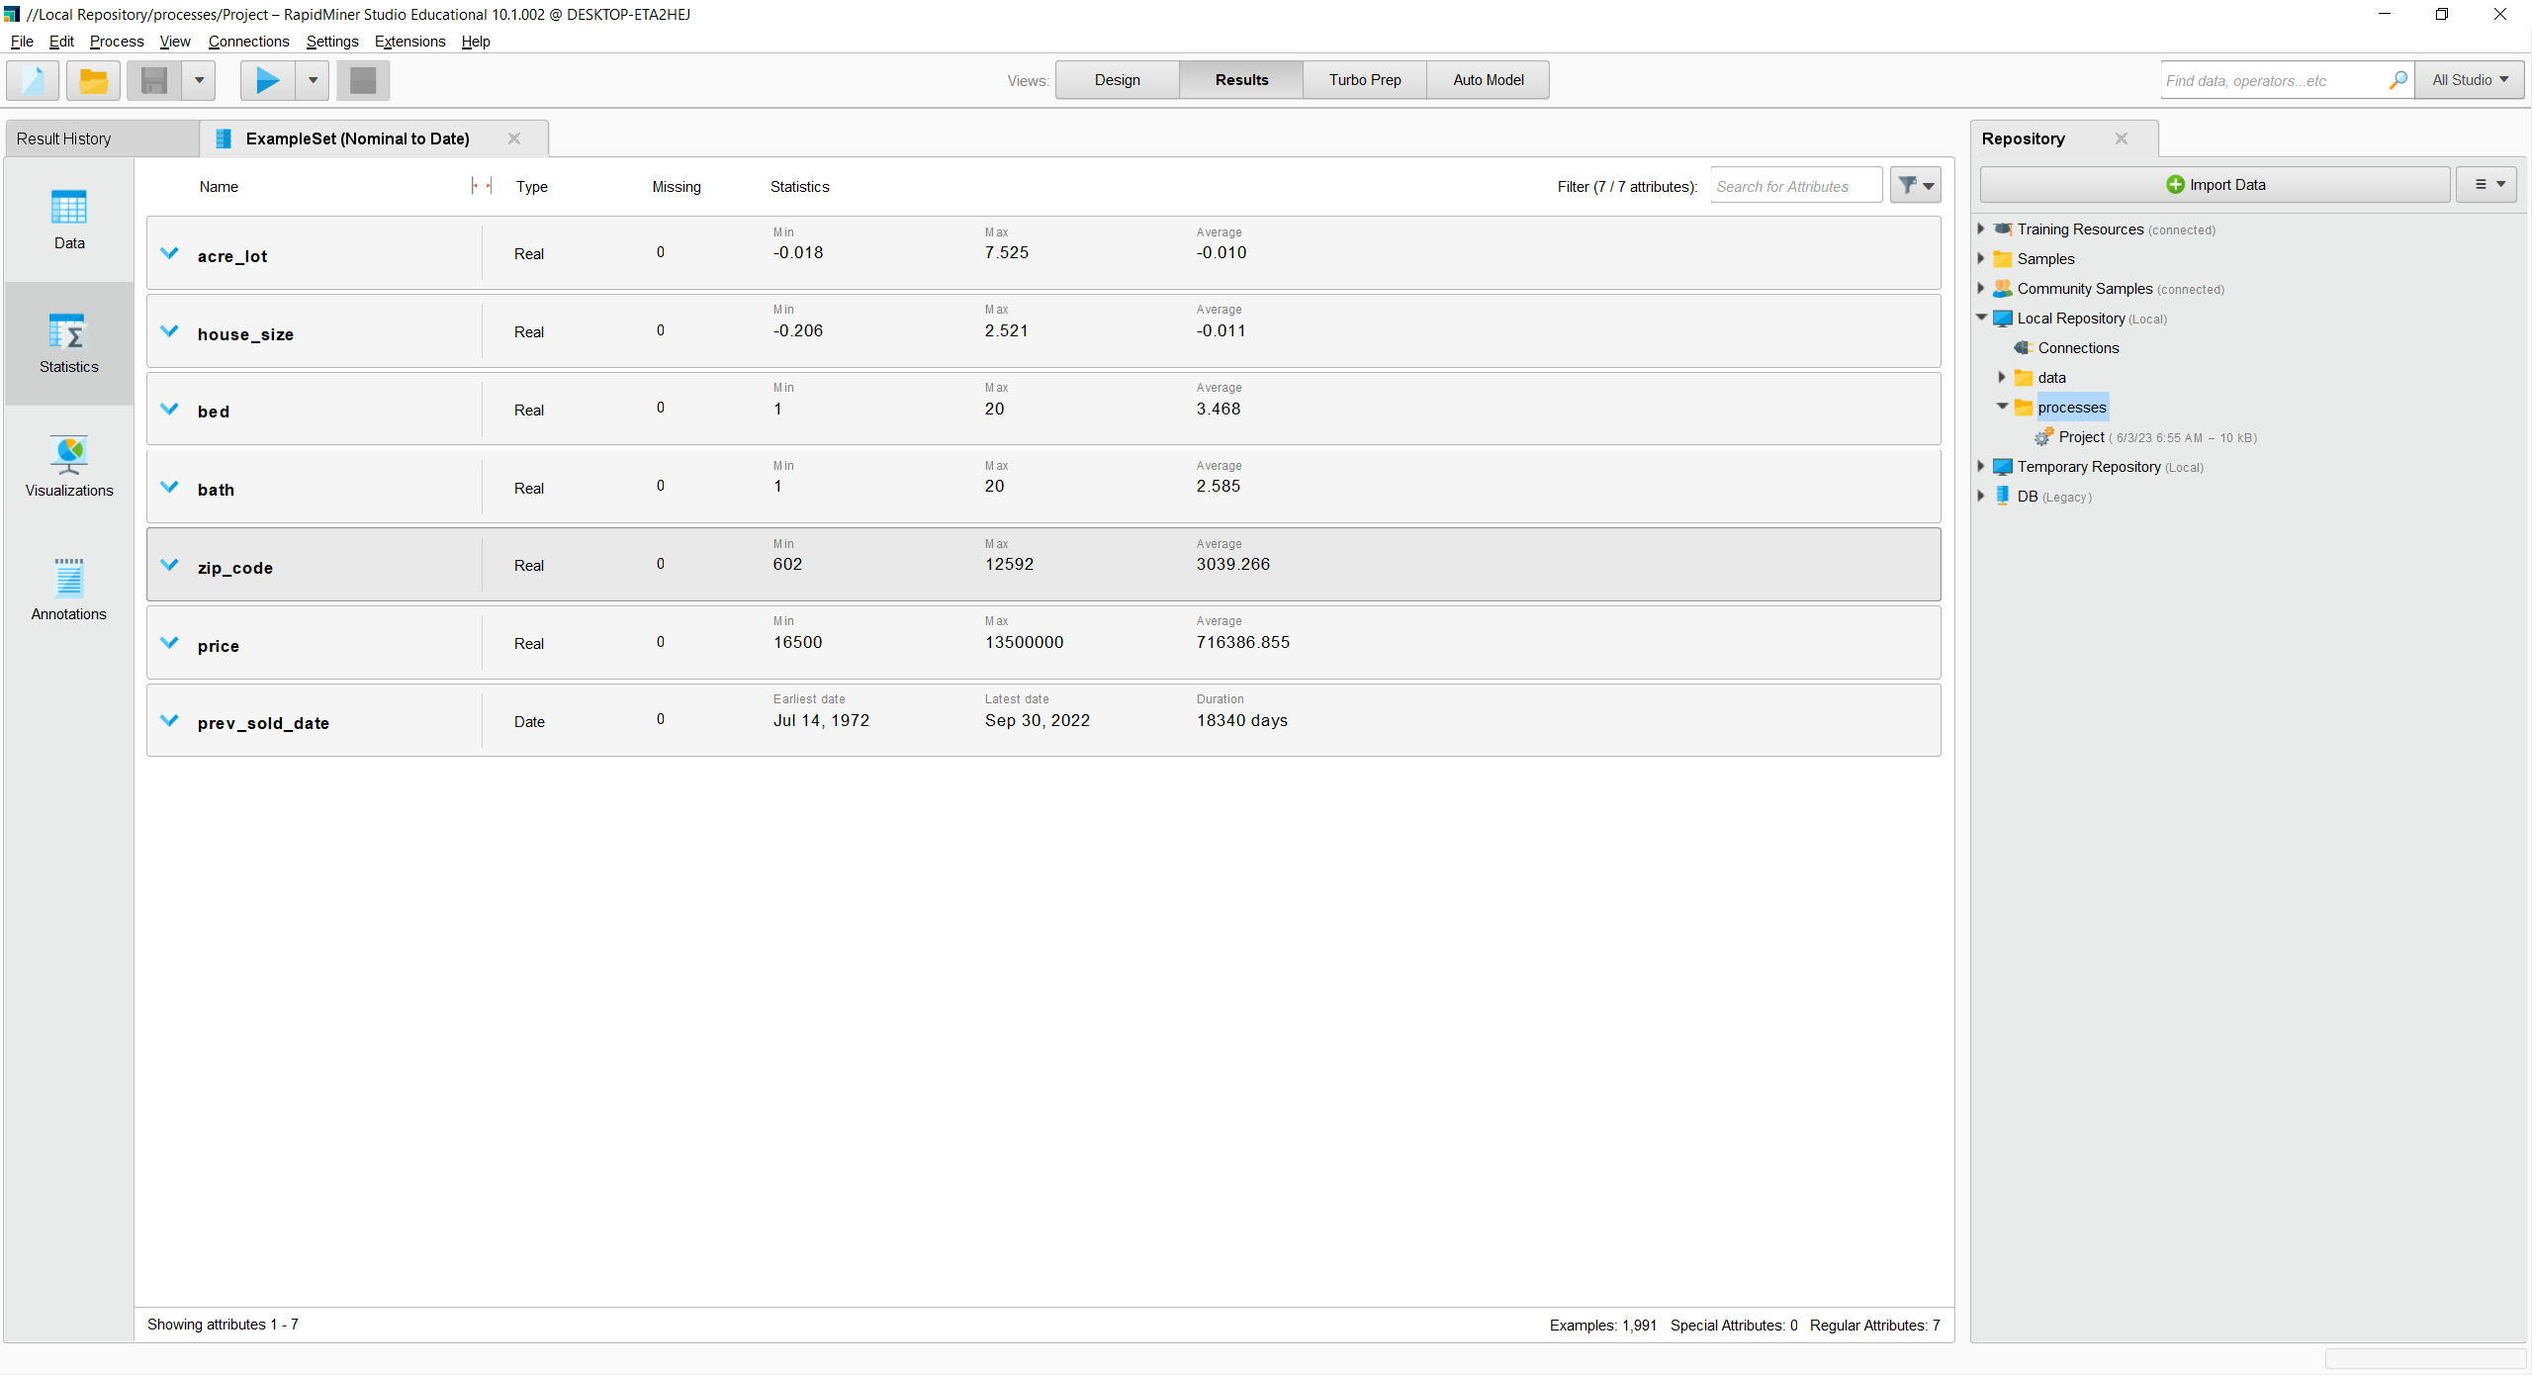

Our Dataset after preprocessing

Now we are done with pre-processing our data. As you can see from the images below our data used to be more than 200 thousand entries with many missing attributes and redundancies.

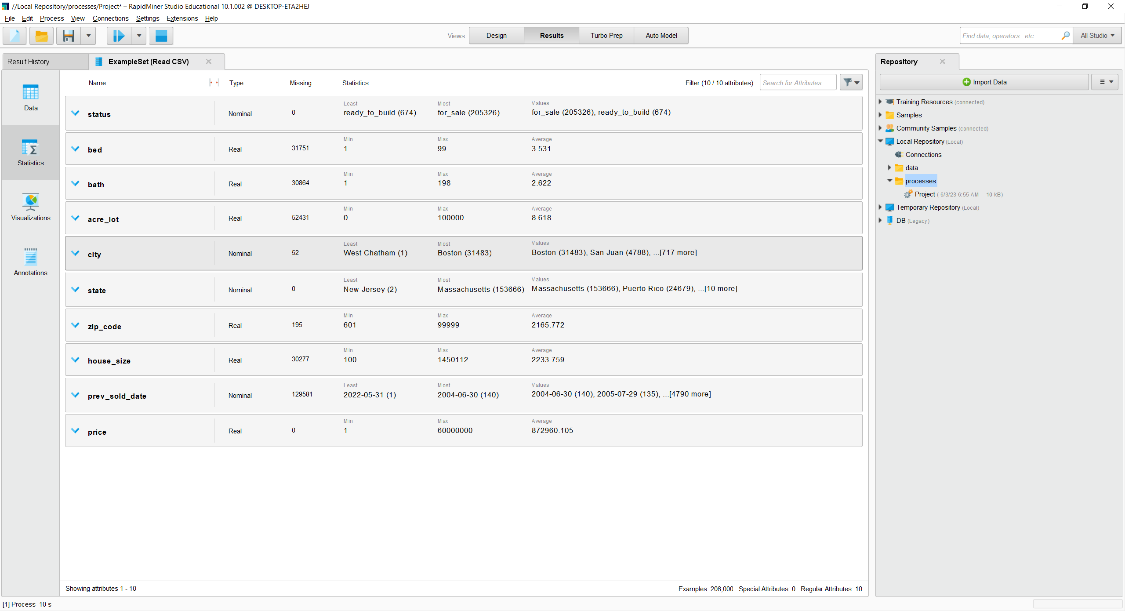

Our Dataset before preprocessing

However, now our data set has a sample size of two thousand with no redundancies, outliers, missing values and with correctly formatted and normalized attributes with reduced dimensionality.

One way to see how our data changed is by looking at our relation between the number of bedrooms and price using line graph plot.

This is how it was:

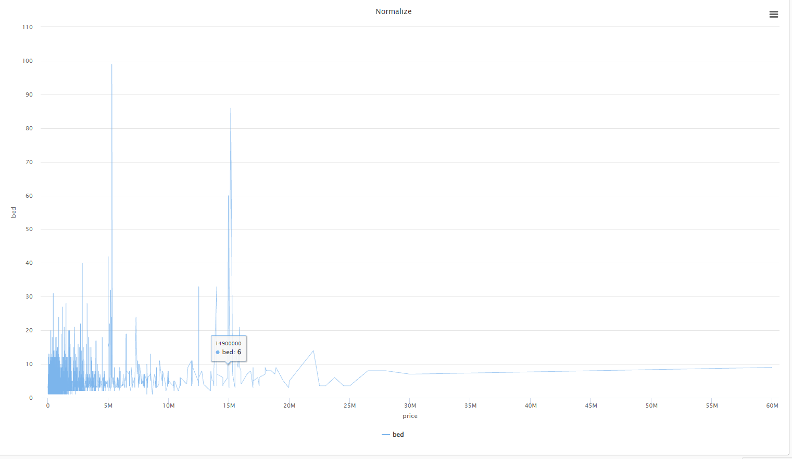

Data before preprocessing

And this is how it became: we can see the effect of preprocessing. The visualization is easier to interpret.

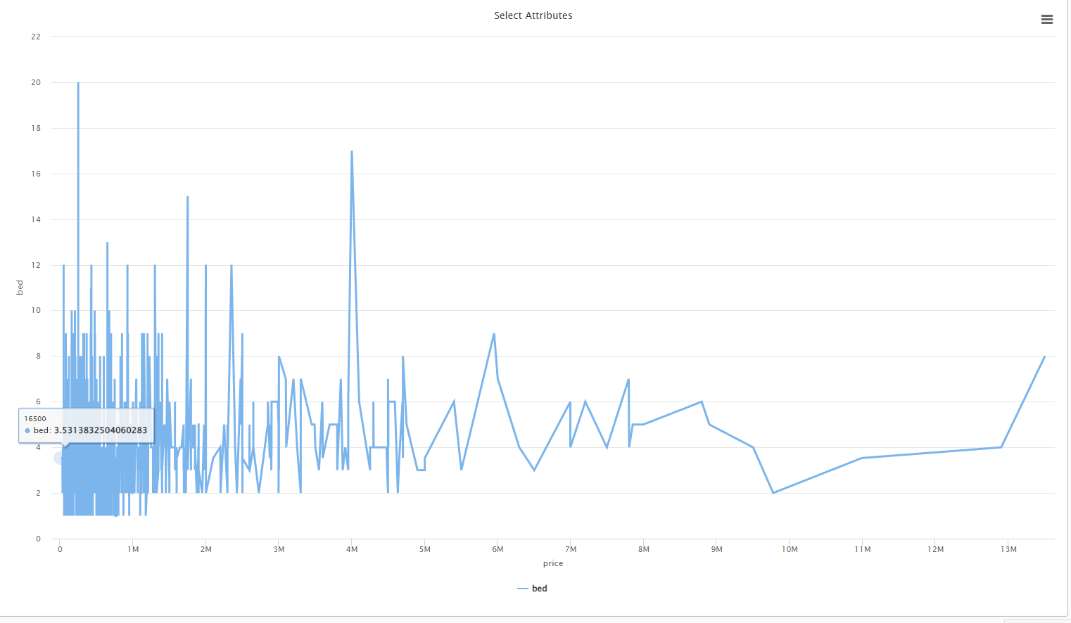

Data after preprocessing

# **Task 4**

Now after our data preprocessing we must build our models. And to build our models we decided to use supervised learning mining techniques since we will be predicting a price attribute which we will be labelling.

Now we will label the price attribute using the set role modifier.

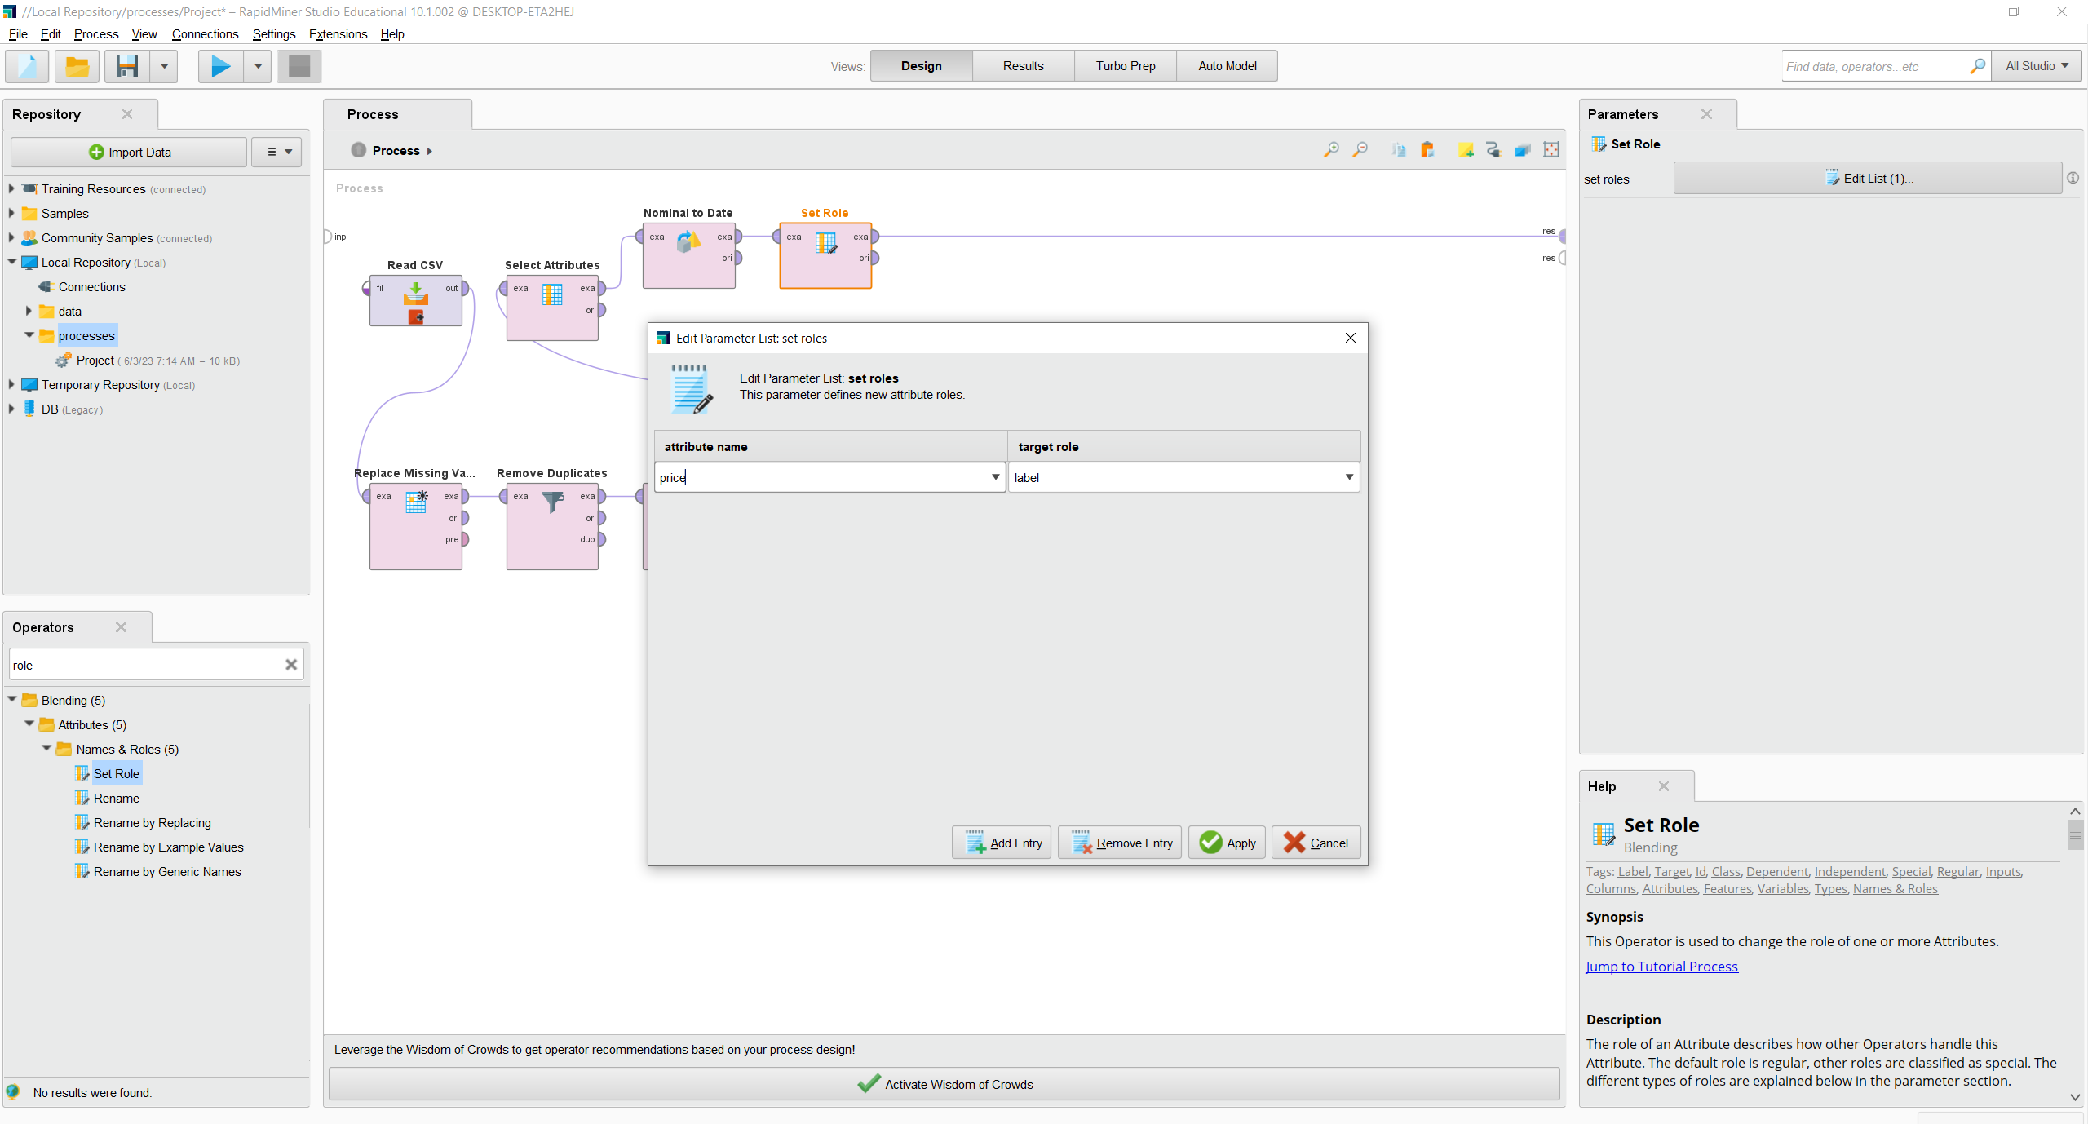

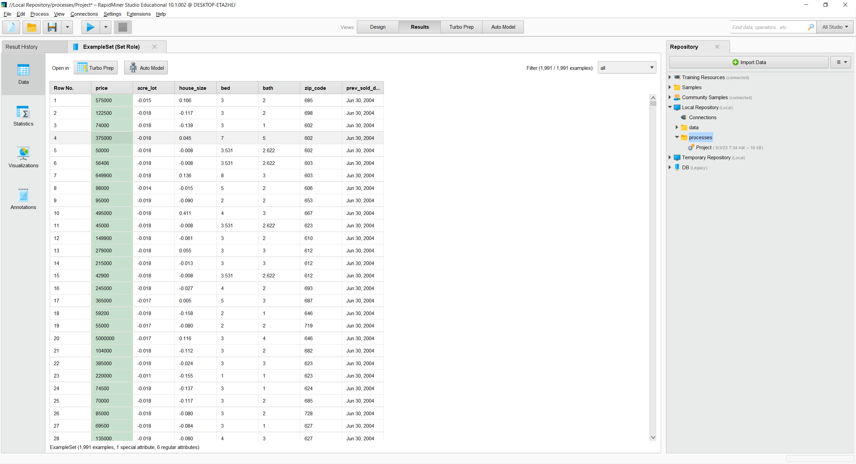

Now as you can see our data is labeled.

Now to build our models since we will be building our models inside cross validation the split of our training and testing data is going to be done by the modifier itself. The reason why we have not used the classification outside of cross validation and split our data is outside is simply because after a few experimentations we found that cross validation usually creates a much more accurate model which is why we decided to use it. However, we will set the number of folds to 15 because it was the best in our experimentation.

Now before we build our first model, we must multiply the data so we can input it to multiple models and to do that we use the multiply modifier.

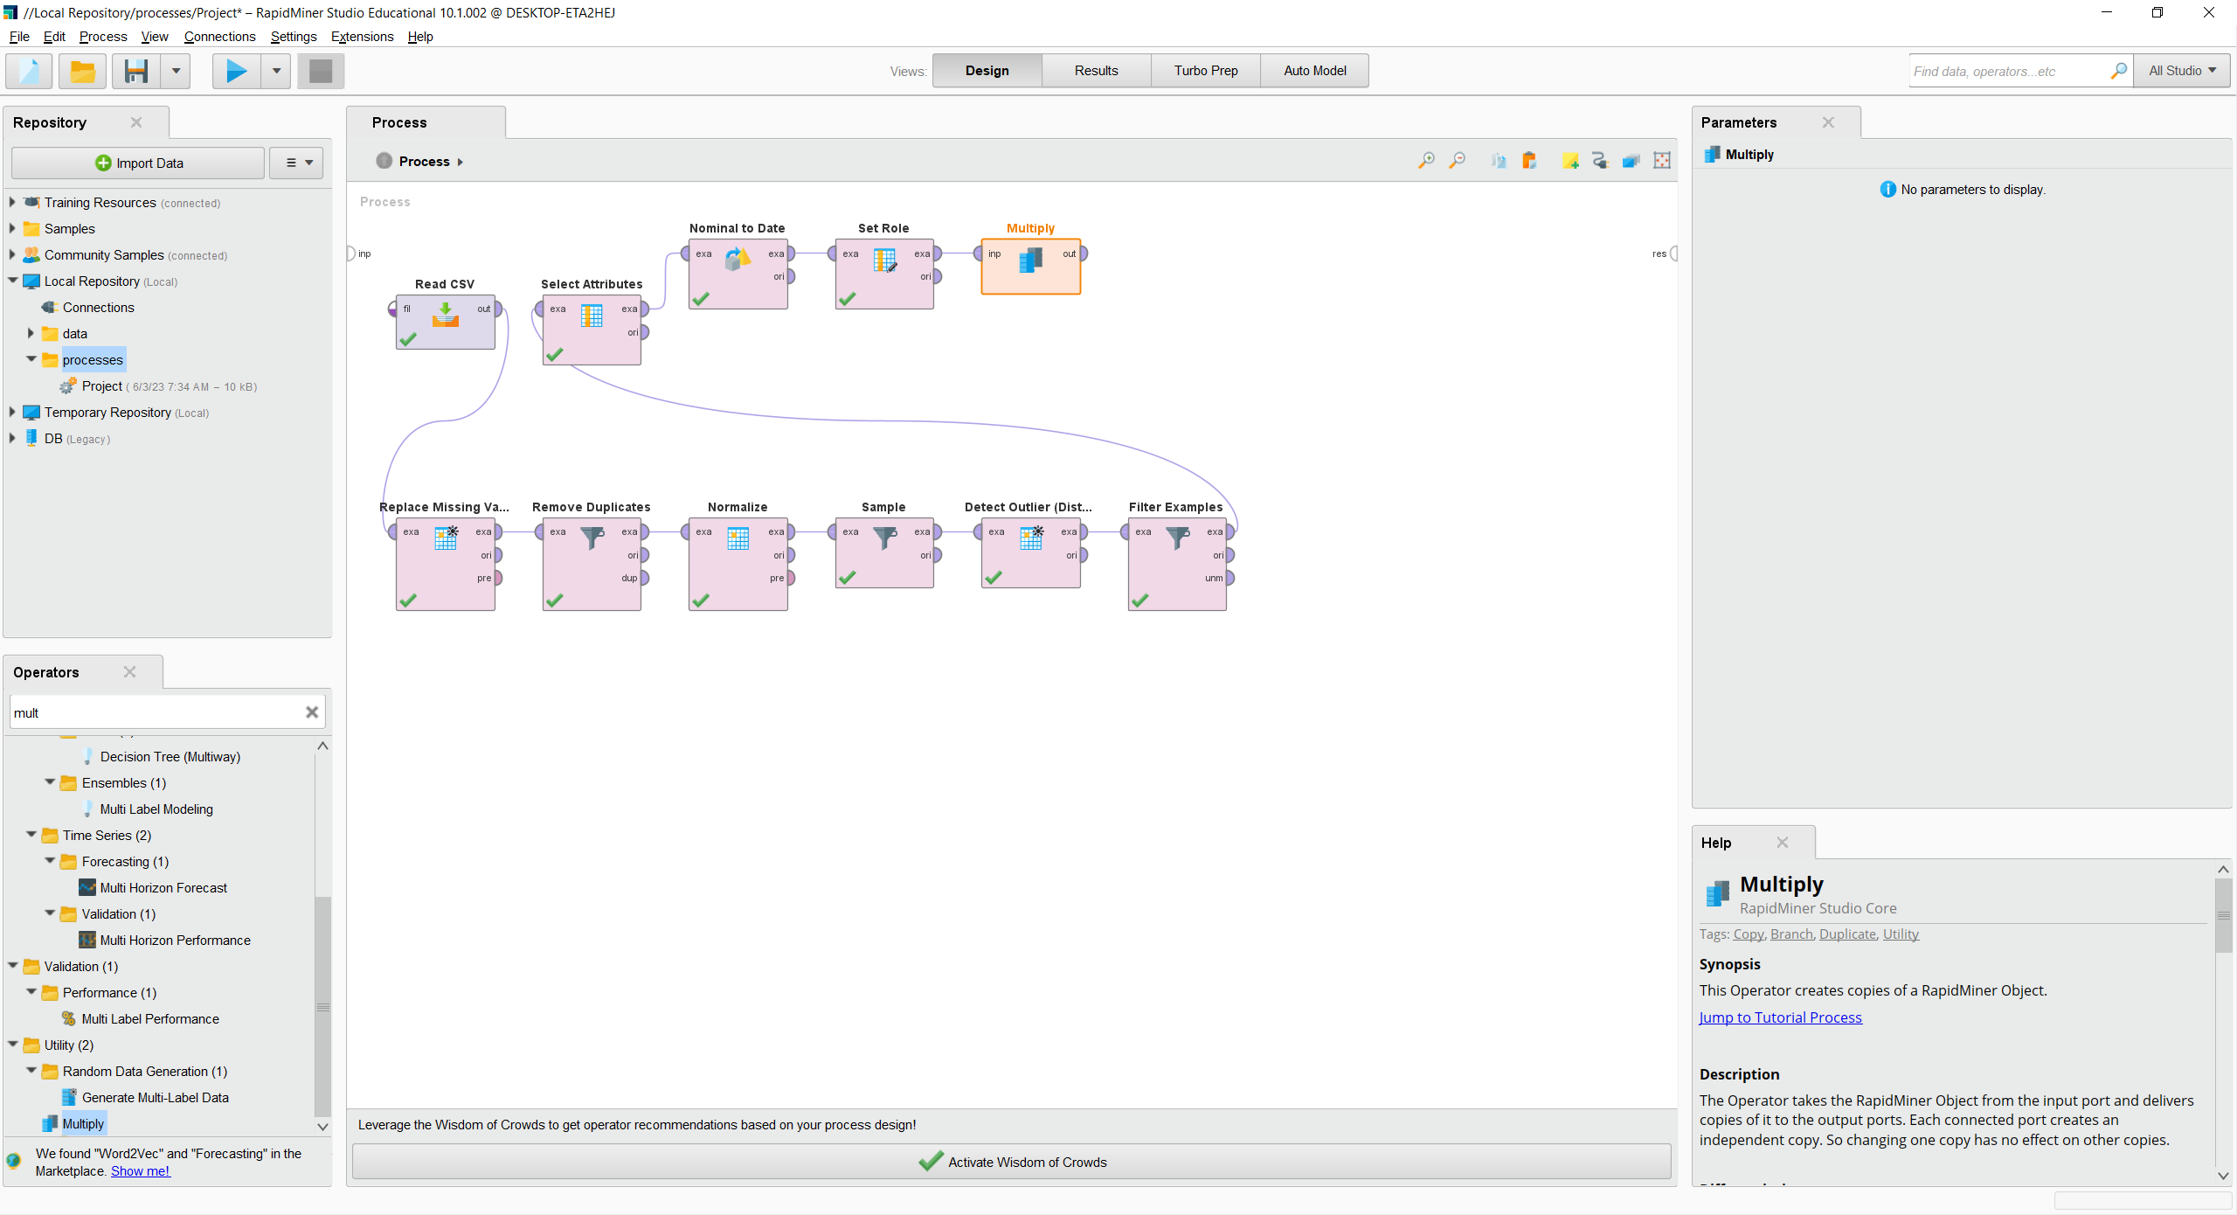

## Linear Regression:

After we add our multiply modifier we will create our first model which will start with cross validation.

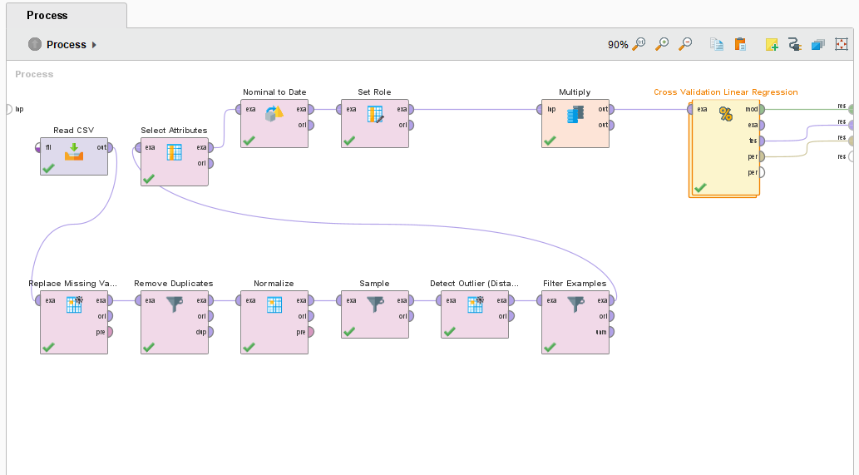

Then we will enter the cross validation and create our first model. The first technique we will use is Linear Regression. Linear regression is widely used for tasks such as predicting house prices, which is our aim, and many other scenarios where a linear relationship is assumed between the variables.

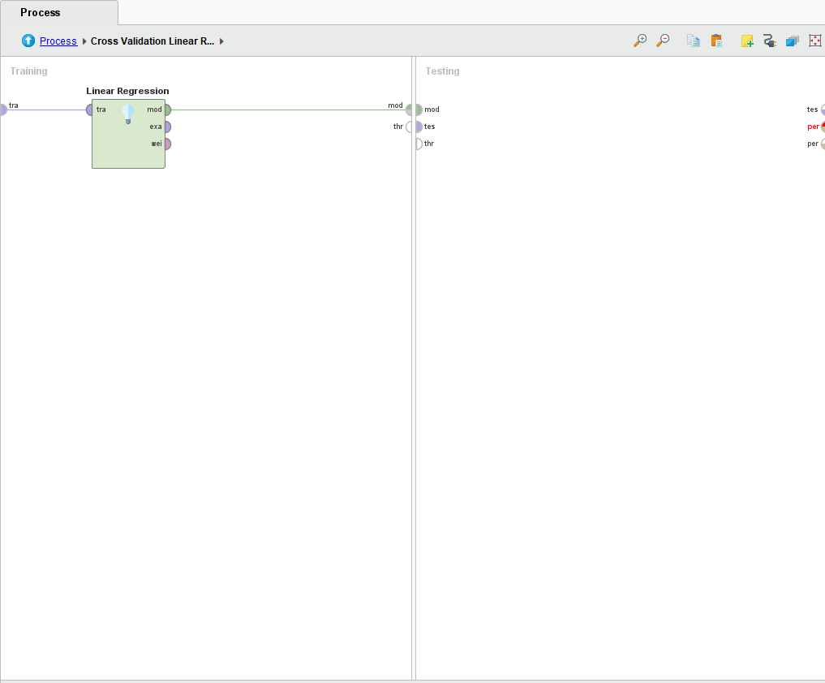

Then we will apply the model and test the performance.

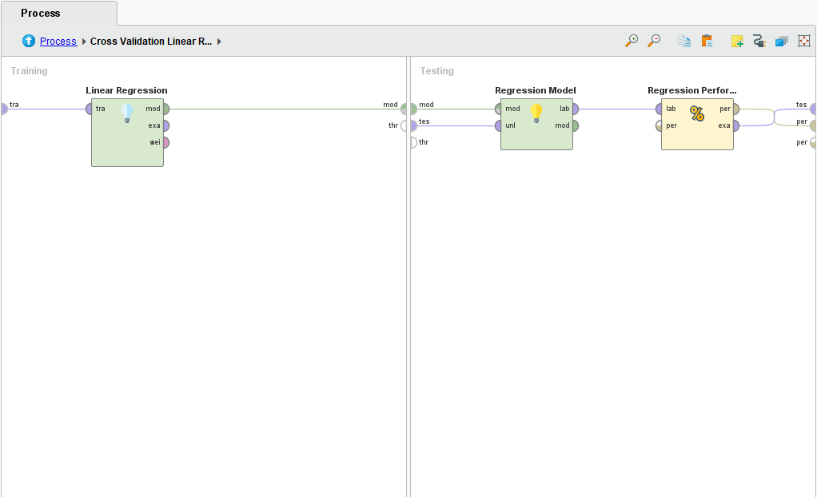

After that we will exit the cross validation and run the model.

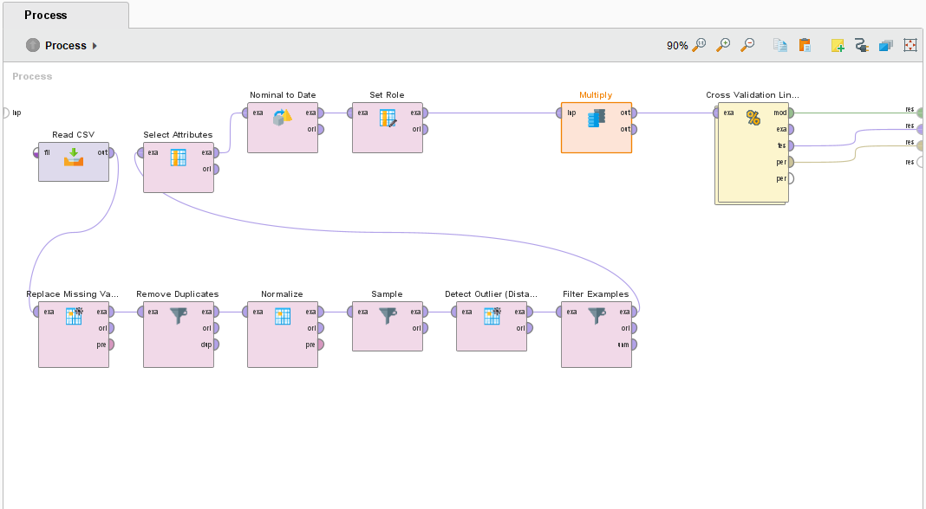

And this is our model along with its performance.

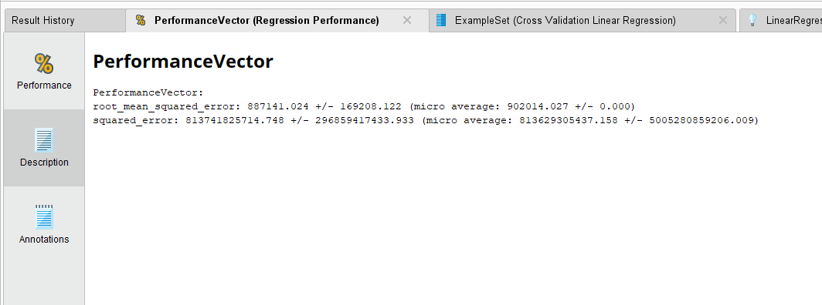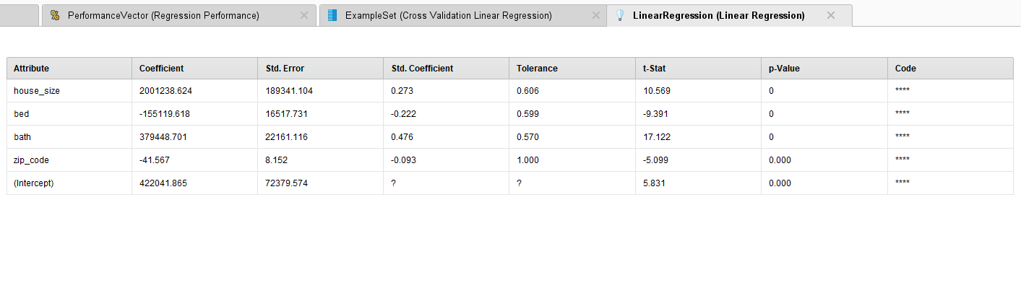

And these are prediction results.

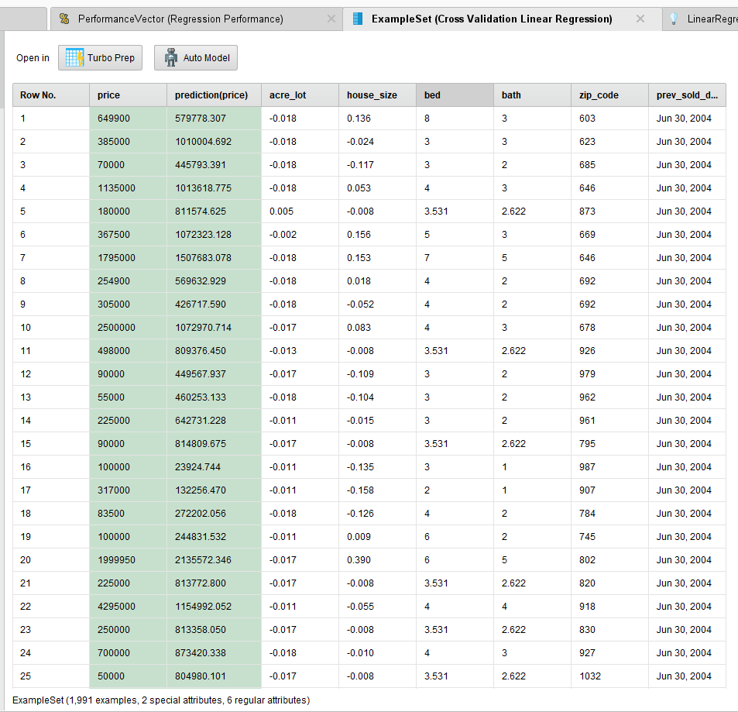

## Random Forest:

Now unto our second model.

We will again be using cross validation.

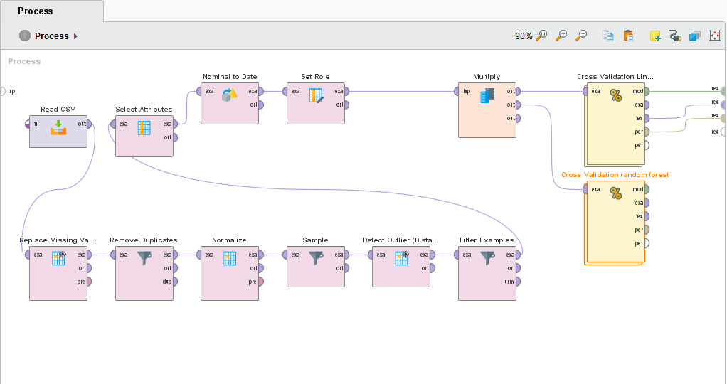

And after we enter this time we will use random forest.

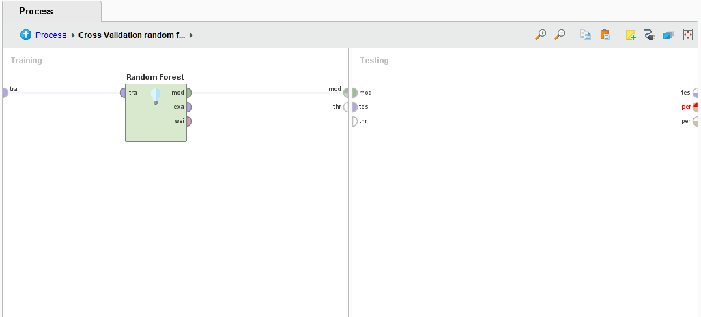

Then we will apply a model and check performance.

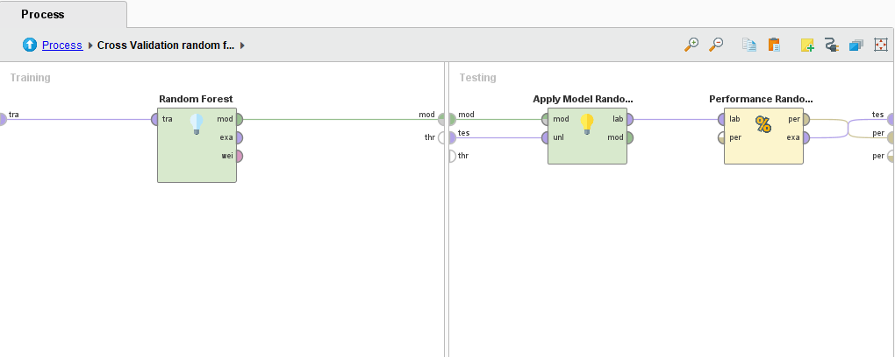

Now we will exit and run.

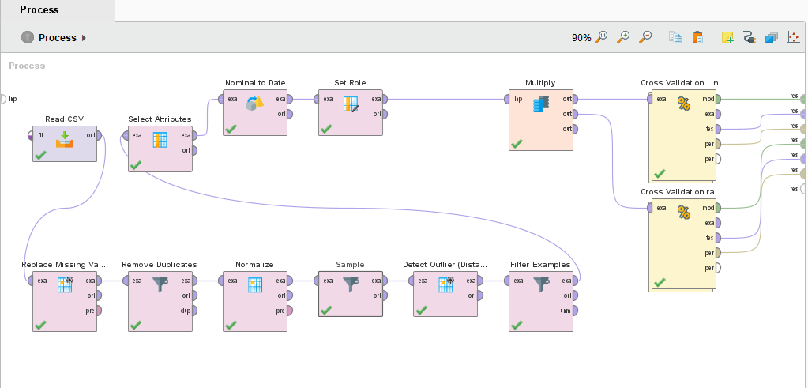

Now this is the model with its performance.

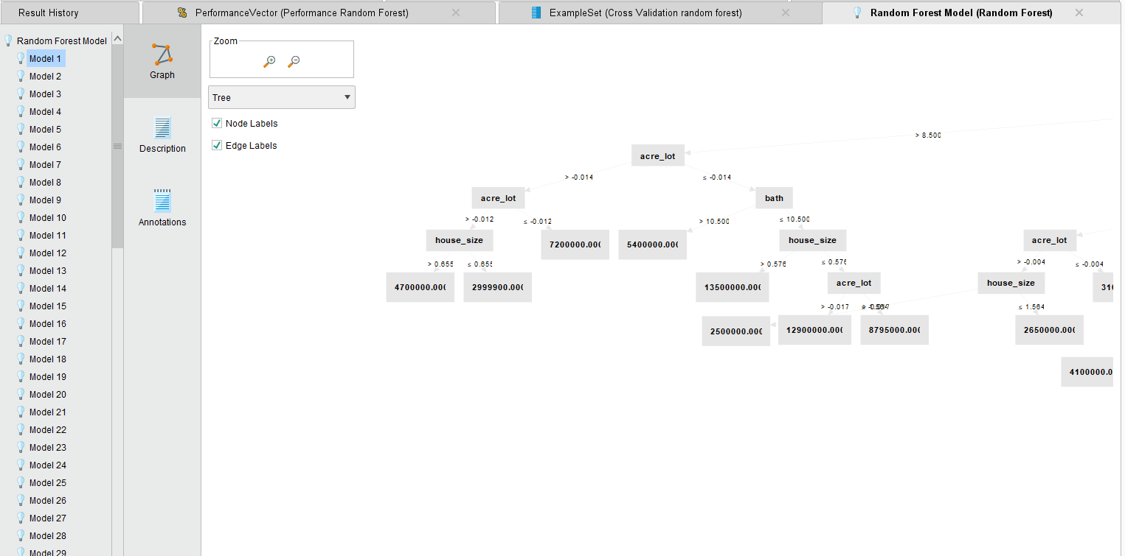

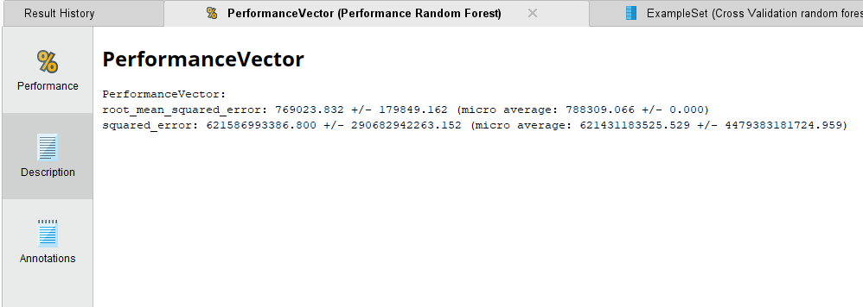

And these are its predictions.

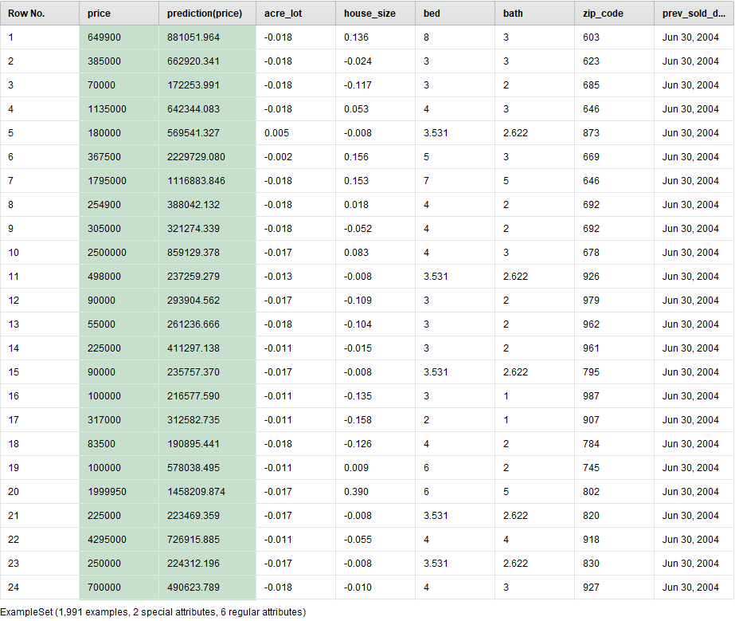

## K-NN:

Now unto our third model.

We will begin by cross validation, then we will use the K-NN classification then we will apply model and test performance.

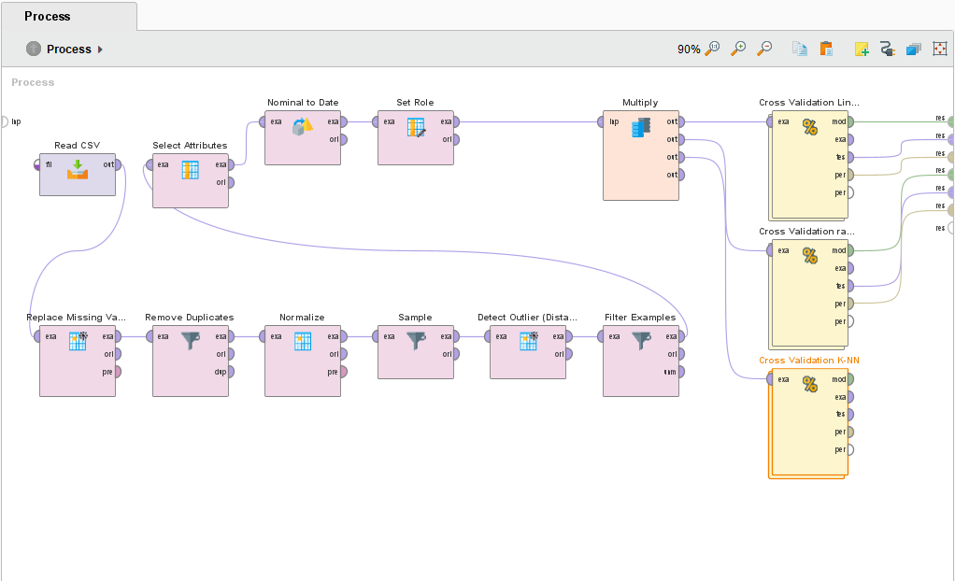

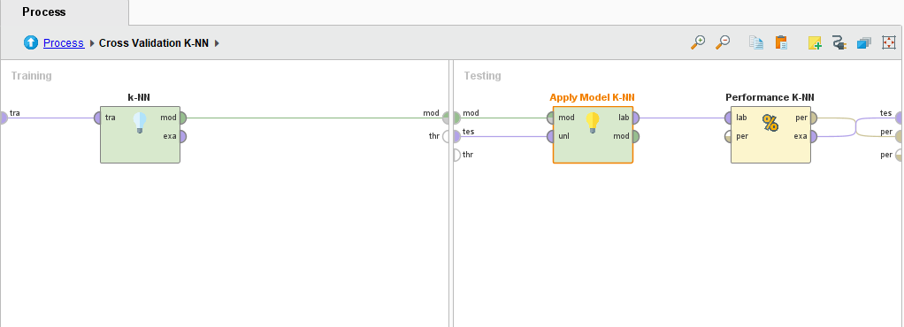

After that we will exit and run.

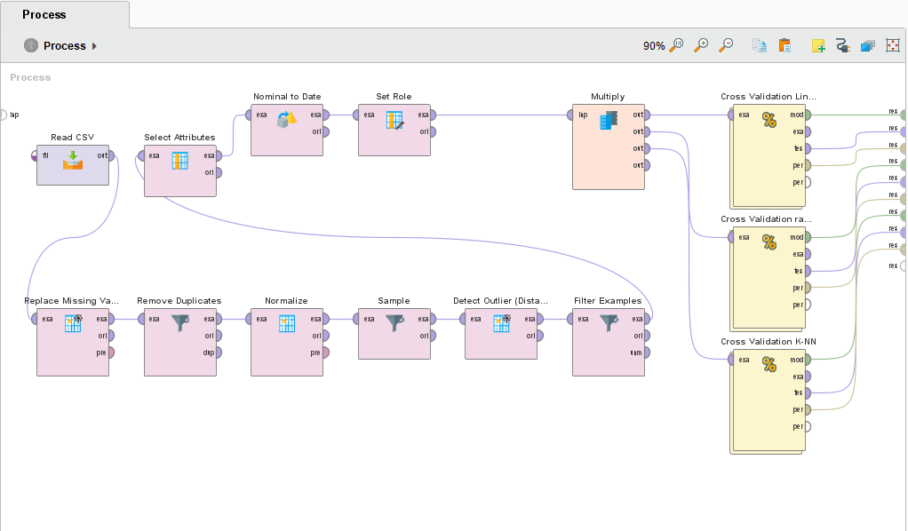

This is the model description.

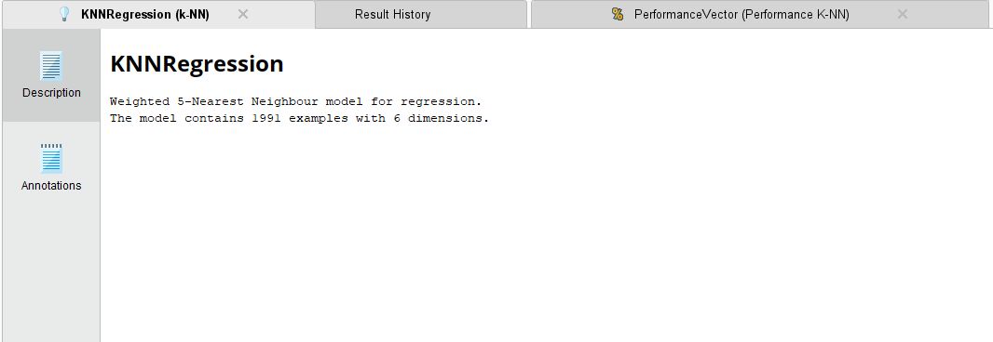

And this is its performance and prediction.

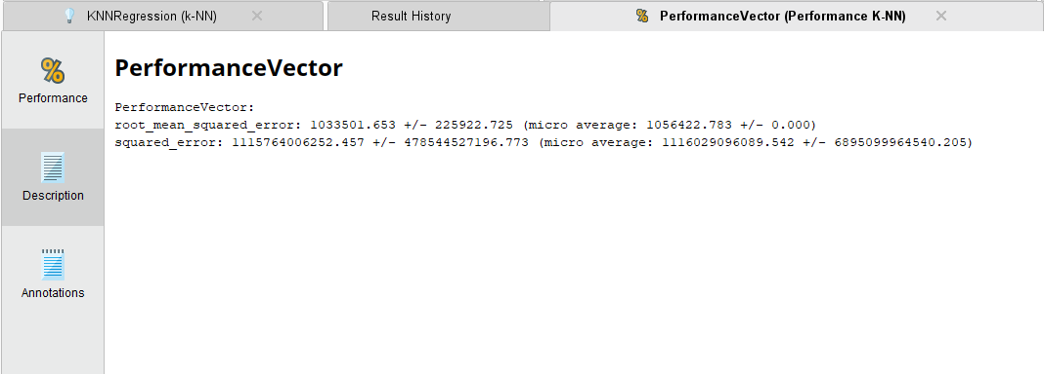

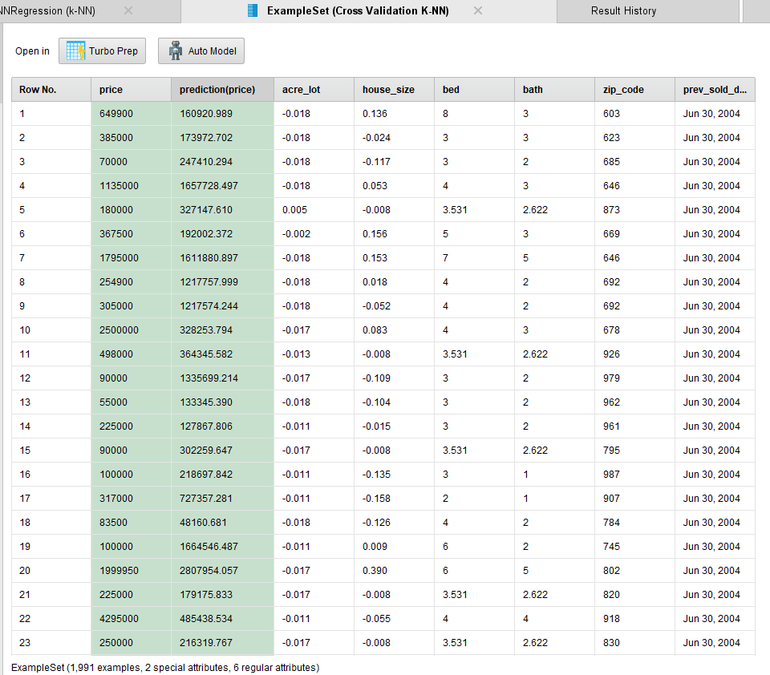

## Ensample Model:

Now unto our ensemble model we will begin with cross validation then we will use the vote ensemble modelling technique.

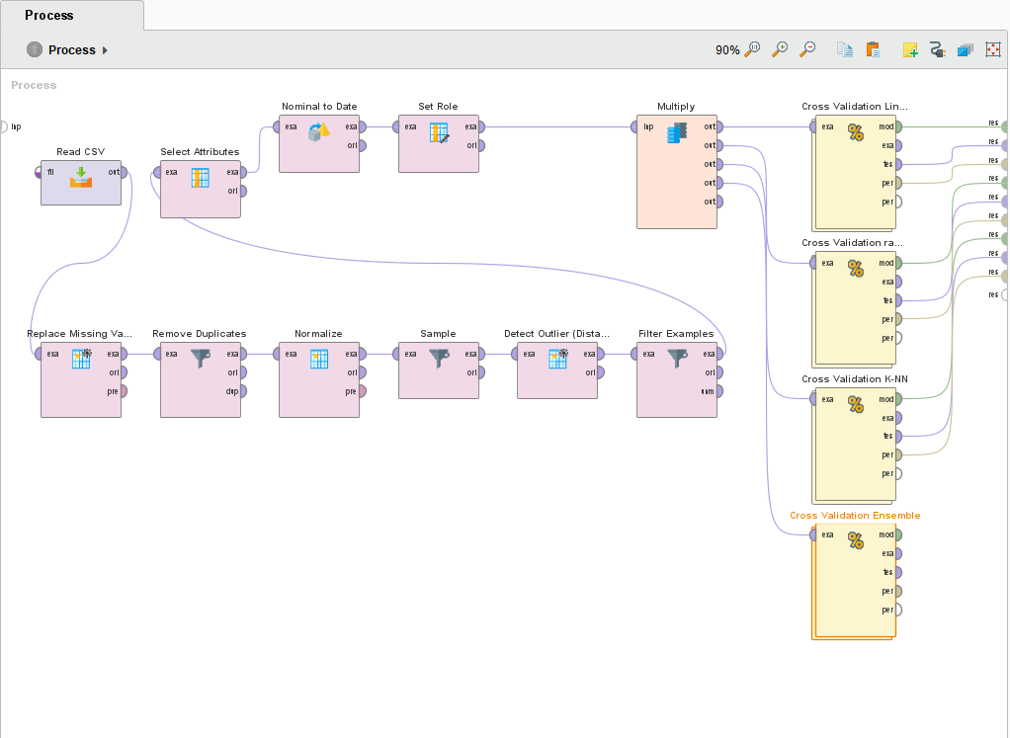

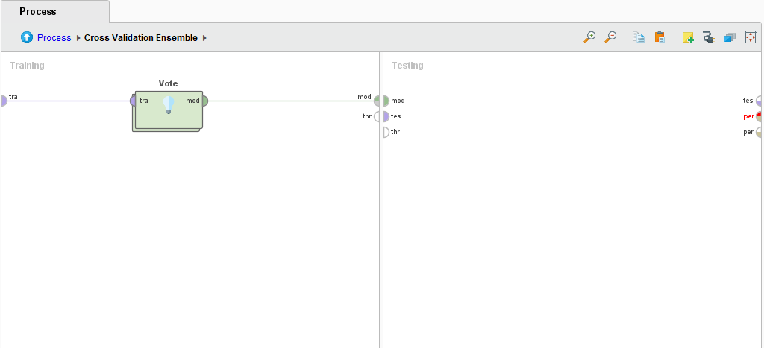

Now we enter the vote then we will use three different models we will use the ones we already used before.

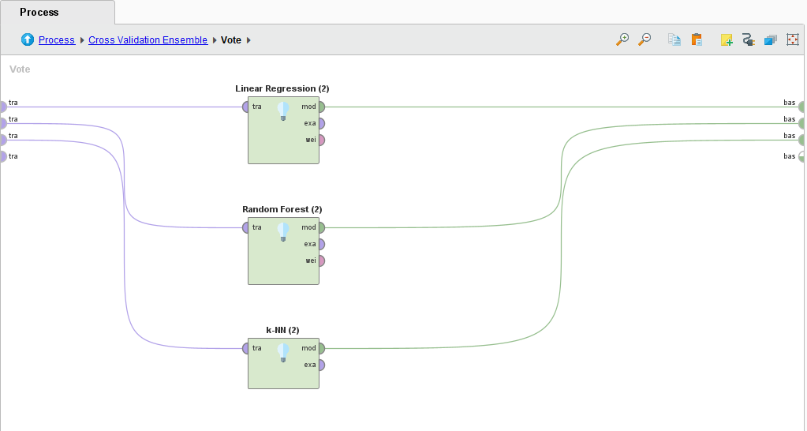

Now we will apply model and test performance.

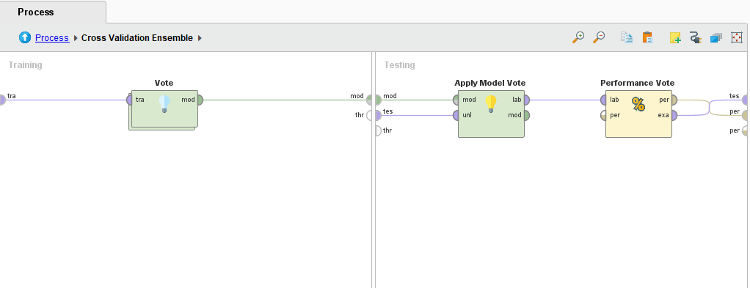

Now we will exit and run.

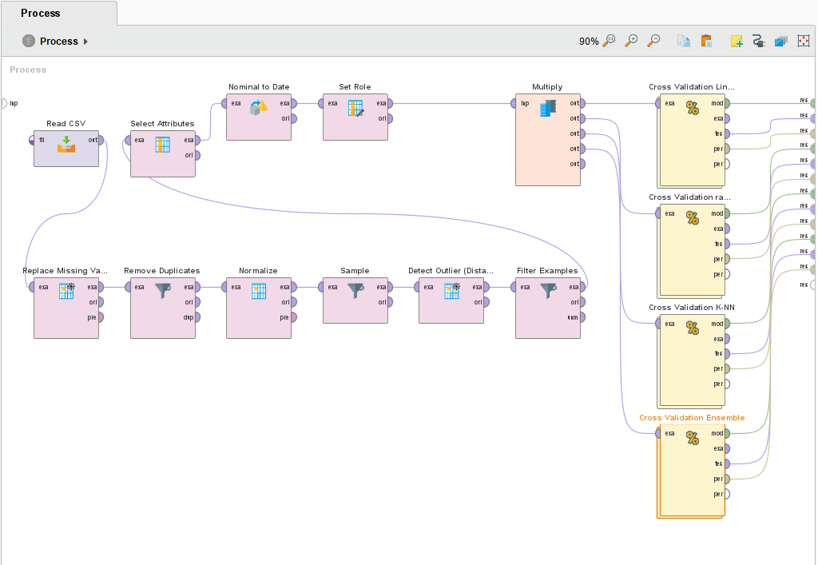

This is the model.

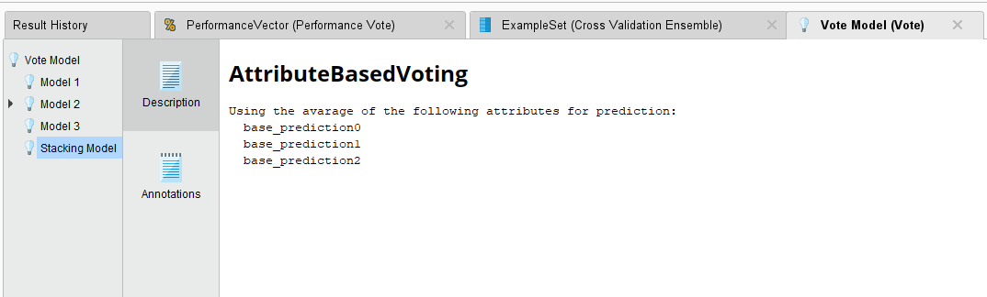

And this is the performance and the prediction.

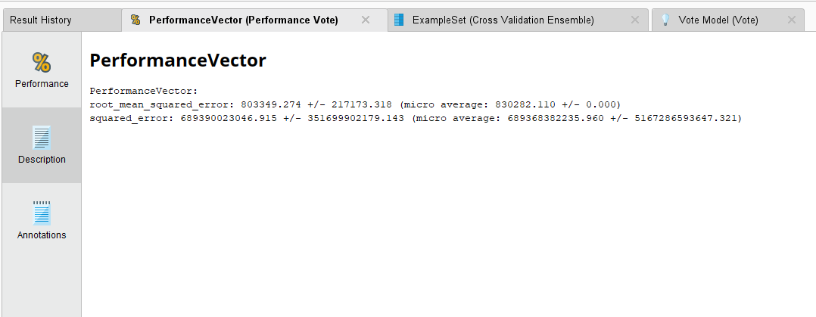

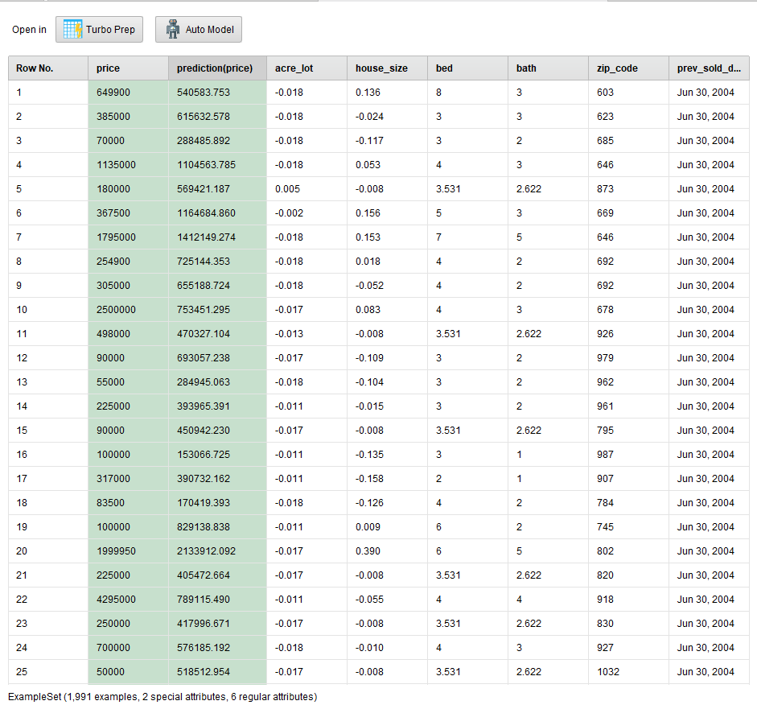

# **Task 5**

## K-NN evaluation:

In this case, the KNN model achieved an RMSE value of 1,006,288.877. This suggests that, on average, the predicted prices deviate from the actual prices by approximately $1,006,288.877. Lower RMSE values indicate better accuracy in predicting house prices.

Additionally, the Mean Squared Error (MSE) metric is used to assess the average squared difference between the predicted and actual house prices. The KNN model obtained an MSE value of 1,125,955,139,465.587, indicating the average squared difference between the predicted and actual prices. Lower MSE values indicate better accuracy.

In conclusion, while the KNN model shows some predictive capability for house prices, there is potential for further refinement to enhance its accuracy. Evaluating and fine-tuning the model with additional techniques may help improve its performance in predicting house prices more accurately.

## Random forest evaluation:

In this case, the Random Forest model achieved an RMSE value of 760,361.170. This suggests that, on average, the predicted prices deviate from the actual prices by approximately $760,361.170. Lower RMSE values indicate better accuracy in predicting house prices.

Additionally, the Mean Squared Error (MSE) metric is used to assess the average squared difference between the predicted and actual house prices. The Random Forest model obtained an MSE value of 643,314,221,889.539, indicating the average squared difference between the predicted and actual prices. Lower MSE values indicate better accuracy.

These metrics provide insights into the performance of the Random Forest model in predicting house prices. Based on the obtained RMSE and MSE values, the model demonstrates relatively good accuracy in predicting house prices compared to other models.

In conclusion, the Random Forest model shows promising predictive capability for house prices, with relatively low RMSE and MSE values. However, it's essential to continue evaluating and refining the model as there is always more room for improvements of the model in predicting house prices accurately.

## Ensample model evaluation:

The ensemble model showed promising results, with an RMSE value of approximately $803,349 and an SE value of 689,390,023,046.915. These metrics indicate the average difference and squared difference, respectively, between the predicted and actual house prices.

Based on the evaluation, we can infer that the ensemble model performs reasonably well in predicting house prices. By leveraging the strengths of the individual models, it achieves improved accuracy. However, there is still room for improvement, as indicated by the variability in predictions and the potential for further fine-tuning to optimize accuracy.

In conclusion, the ensemble model shows promise in predicting house prices by combining the strengths of linear regression, random forest, and KNN models. The provided performance metrics highlight its overall accuracy, while also pointing out areas for further fine-tuning and optimization.

# **Task 6**

During this project, we developed and evaluated several models, including linear regression, random forest, KNN and Ensample model, to predict house prices. In this section, we compare the performance of these models, highlight the insights and inferences obtained from the entire process, and provide recommendations to improve the business problem at hand.

## Model Comparison and Contrast:

After comprehensive evaluation, the random forest model emerged as the most accurate in predicting house prices. It exhibited the lowest Root Mean Squared Error (RMSE) and Mean Squared Error (MSE), signifying its superior performance compared to the linear regression and KNN models. The linear regression model performed moderately, while the KNN model demonstrated higher prediction errors.

## Insights and Inferences:

Through this project, we gained valuable insights into the factors influencing house prices. The attributes considered, such as the number of bedrooms, number of bathrooms, city, state, house size, acre_lot, and zipcode, played a significant role in predicting house prices accurately. We observed that the random forest model's ability to capture complex relationships among these attributes contributed to its superior performance. In contrast, the KNN model's performance was affected by the choice of the K value, impacting its prediction accuracy. Pre-processing techniques, such as handling missing data, removing outliers, and normalizing the data, were found to improve the overall performance of the models.

## Recommendations:

Based on our findings, we offer the following recommendations to further enhance the accuracy of house price prediction models:

* **Additional Attributes:** Consider collecting additional relevant attributes, such as proximity to schools, amenities, crime rates, and transportation facilities. Incorporating these factors could provide a more comprehensive understanding of house prices.
* **Advanced Regression Techniques:** Explore more advanced regression techniques, such as gradient boosting or neural networks. These models have the potential to capture intricate patterns and relationships within the data, further improving prediction accuracy.
* **Hyperparameter Tuning:** Fine-tune the hyperparameters of the models, such as the number of trees in the random forest or the K value in the KNN model. Optimizing these parameters can have a significant impact on the models' performance and prediction accuracy.
* **Regular Dataset Updates:** Continuously update the dataset with the latest market information. Housing markets can be dynamic, and incorporating up-to-date data ensures that the models adapt to changing trends, thereby enhancing their accuracy over time.

In conclusion, the random forest model outperformed the linear regression, KNN, and ensemble models in predicting house prices accurately. The insights gained from the models emphasize the significance of relevant attributes and effective preprocessing techniques. By implementing the recommended strategies, such as incorporating additional attributes, exploring advanced regression techniques, tuning hyperparameters, and updating the dataset regularly, the models can be further improved to provide more precise predictions and support decision-making in the real estate industry.

## Reflection:

Throughout the course of this project, we have gained valuable insights and experiences in developing a house price prediction model using data mining techniques. Reflecting on the work completed, we have identified several areas of learning and potential improvements that could have enhanced the project's outcomes.

The project emphasized the significance of data preparation and pre-processing, including handling missing data, addressing redundancy, and normalizing the data. Model selection and evaluation were explored use of linear regression, random forest, KNN, and an ensemble model. The inclusion of relevant features improved the models' performance, highlighting the importance of feature engineering. However, there are areas for improvement, such as enhancing data quality and scope, optimizing the models through hyperparameter tuning, and incorporating time-series analysis to capture market trends. The project provided valuable insights and recommendations for future projects, including the need for a collaborative approach and continuous improvement in accuracy and relevance for real estate stakeholders.

Overall, the project was a valuable learning experience in developing house price prediction models using data mining techniques. The insights gained and recommendations provided contribute to the ongoing pursuit of more accurate and meaningful predictions in the real estate industry.